# Project Description

QuickGPT is a MERN stack based AI chatbot web application inspired by ChatGPT. It allows users to chat with an AI model, generate images, and explore community-shared posts. The system includes a credit-based model in which users must purchase credits to use AI features. The project also provides stripe-based payment integration, JWT authentication and clean, responsive frontend UI.

# Project Objective

* + To develop a functional AI chatbot, using MERN stack
  + To allow users to generate text and images using AI
  + To implement a credit-based usage system
  + To integrate secure payments using stripe
  + To provide a clean and responsive UI using modern web technologies

# Technology Stack

* **Frontend**
  + React.js
  + Tailwind CSS
* **Backend**
  + Node.js
  + Express.js
  + MongoDB + mongoose
* **Authentication**
  + JSON web token
* **Payments**
  + Stripe API
* **AI Features**
  + Google Gemini API
* **Third-party API**
  + Official Joke API

# Links

* **GitHub repository link**
  + <https://github.com/AP-anjali/QuickGPT_CC_PROJECT>
* **Deployed website link**
  + **Frontend :** <https://202412063-quick-gpt.vercel.app/>
  + **Backend :** <https://quick-gpt-server-plum.vercel.app/>

# Contribution

|  |  |  |
| --- | --- | --- |
| Student ID | Name | Contribution |
| 202412063 | Anjali Patel | Entire Backend and testing |
| 202412065 | Dhara Patel | Entire Frontend |
| 202412088 | Hirwa Saraiya | Payment integration |
| 202412121 | Viraj Sharma | Third-party integration |

# System Architecture [as a development view]

# React Client → Express Server → MongoDB

# ↑ ↓

# Stripe Checkout ← Webhooks

* **Flow Summary :** 
  + User interacts with frontend
  + API calls sent to backend
  + Backend verifies token and then processes request if valid tocken
  + AI answer generation and credits deducted
  + Payments handled via stripe checkout
  + MongoDB stores users, chats, messages, credits & transactions

# Architecture Diagram [as a deployment view]

* **Step 1 : define the business problem, that needs to be solved** 
  + QuickGPT must allow end users to interact with an AI chat/image-generation service and a community posts area while enforcing a credit-based pay-to-use model, providing a secure, responsive UI and safe, scalable backend handling of AI API calls, payments(stripe), authentication(JWT), and community content.
  + Primary success criteria :
    - Low-latency chat and image generation for paying users
    - Secure payments and credit accounting (no free bypass)
    - Clear separation of real-time request handling VS background work
    - Observability and fault-tolerance
* **Step 2 : define the necessary business process, that needs to be automated by the software application**
  + Sub-function 1 : Interact with the customer (presentation) : user interface
  + Sub-function 2 : Provide application logic to automate business process
    - Customer logic
    - Fulfillment logic
  + Sub-function 3 : Share and manipulate data
    - Customer information
    - Chat data
* **Step 3 : translate the business process into the requirements (functions and features) for the software**
  + **Functional :** 
    - JWT authentication
    - Stripe integration
    - Credit accounting microservice
    - DB storage
  + **Non-Functional :** 
    - Horizontal scalability, auto scaling
    - High availability for critical services
* **Step 4 : define the software architecture diagram : we have the following sub-functions (from step 2)**
  + Layer 1 : **thin client** : enable the graphical user interface for the client on client’s customer
  + Layer 2 : **to realize sub-function 1 :** present the necessary information (chat and published images, ...), create the GUI for the client, and enable the visualization, data entry, communication with the application and output of results
  + Layer 3 : **to realize sub-function 2 :** perform the application logic
    - Customer logic and fulfillment logic
  + Layer 4 : **to realize sub-function 3 :** manipulate and share data

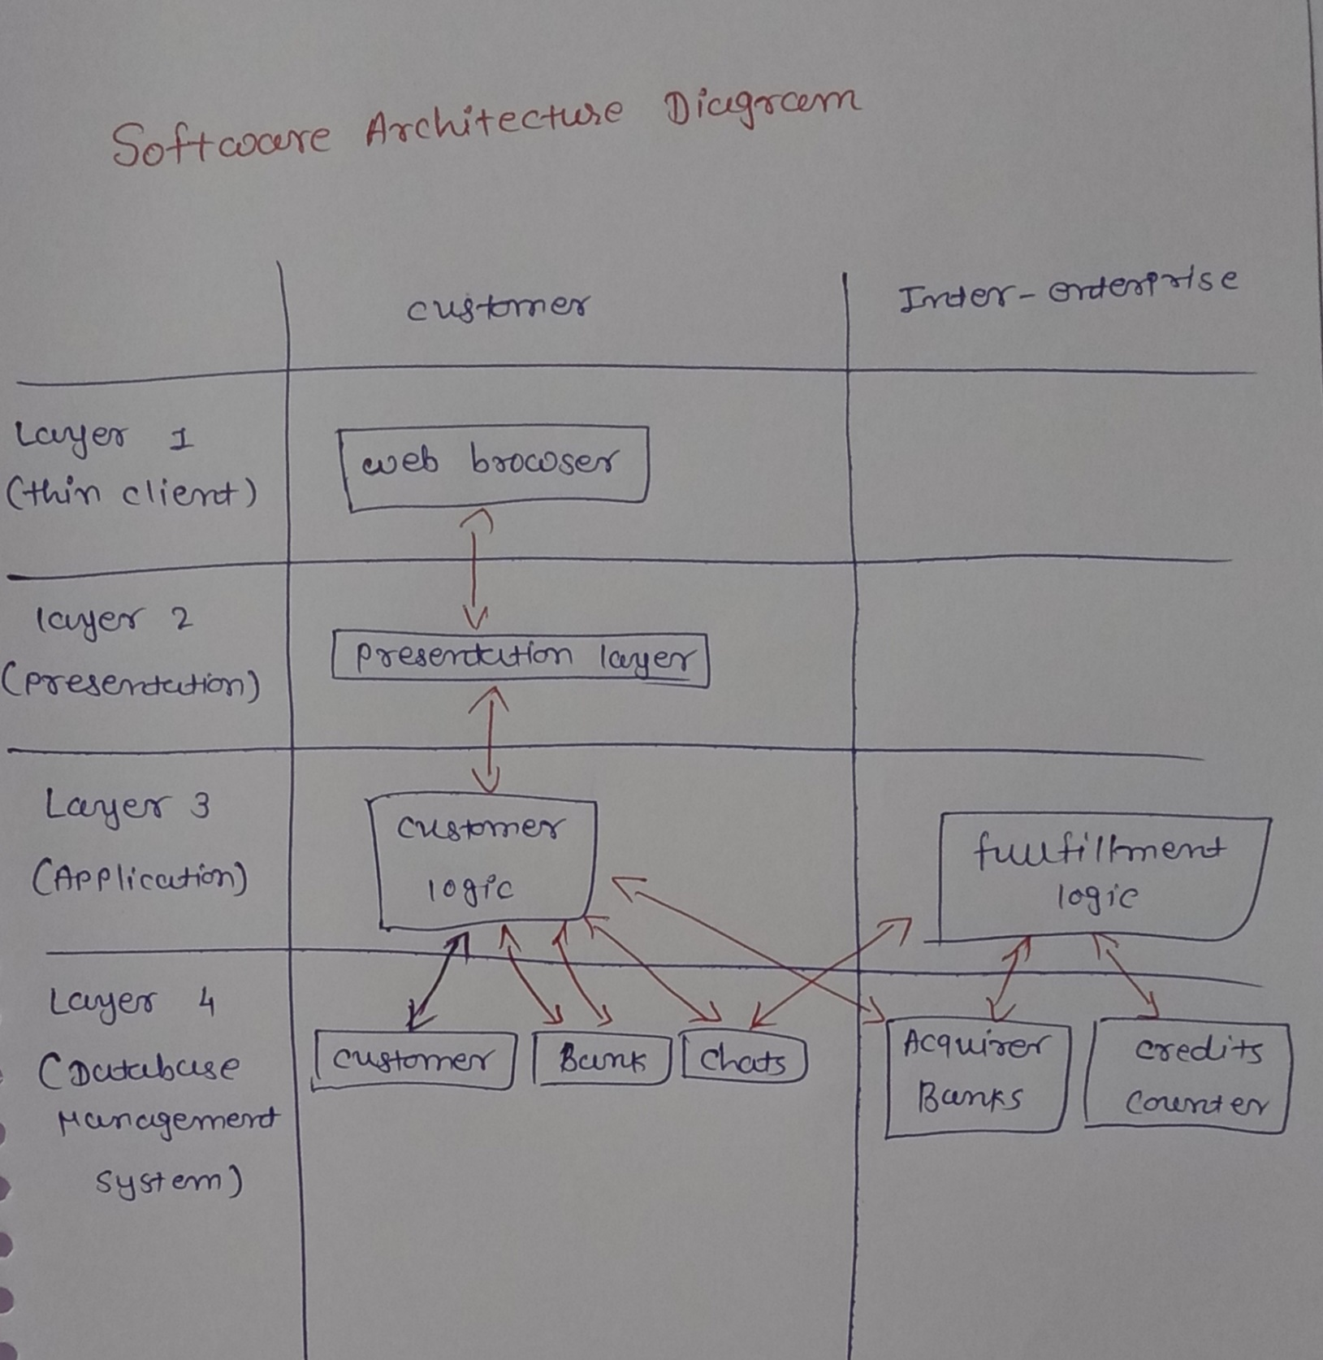

* **Step 5 : define the hardware architecture diagram**

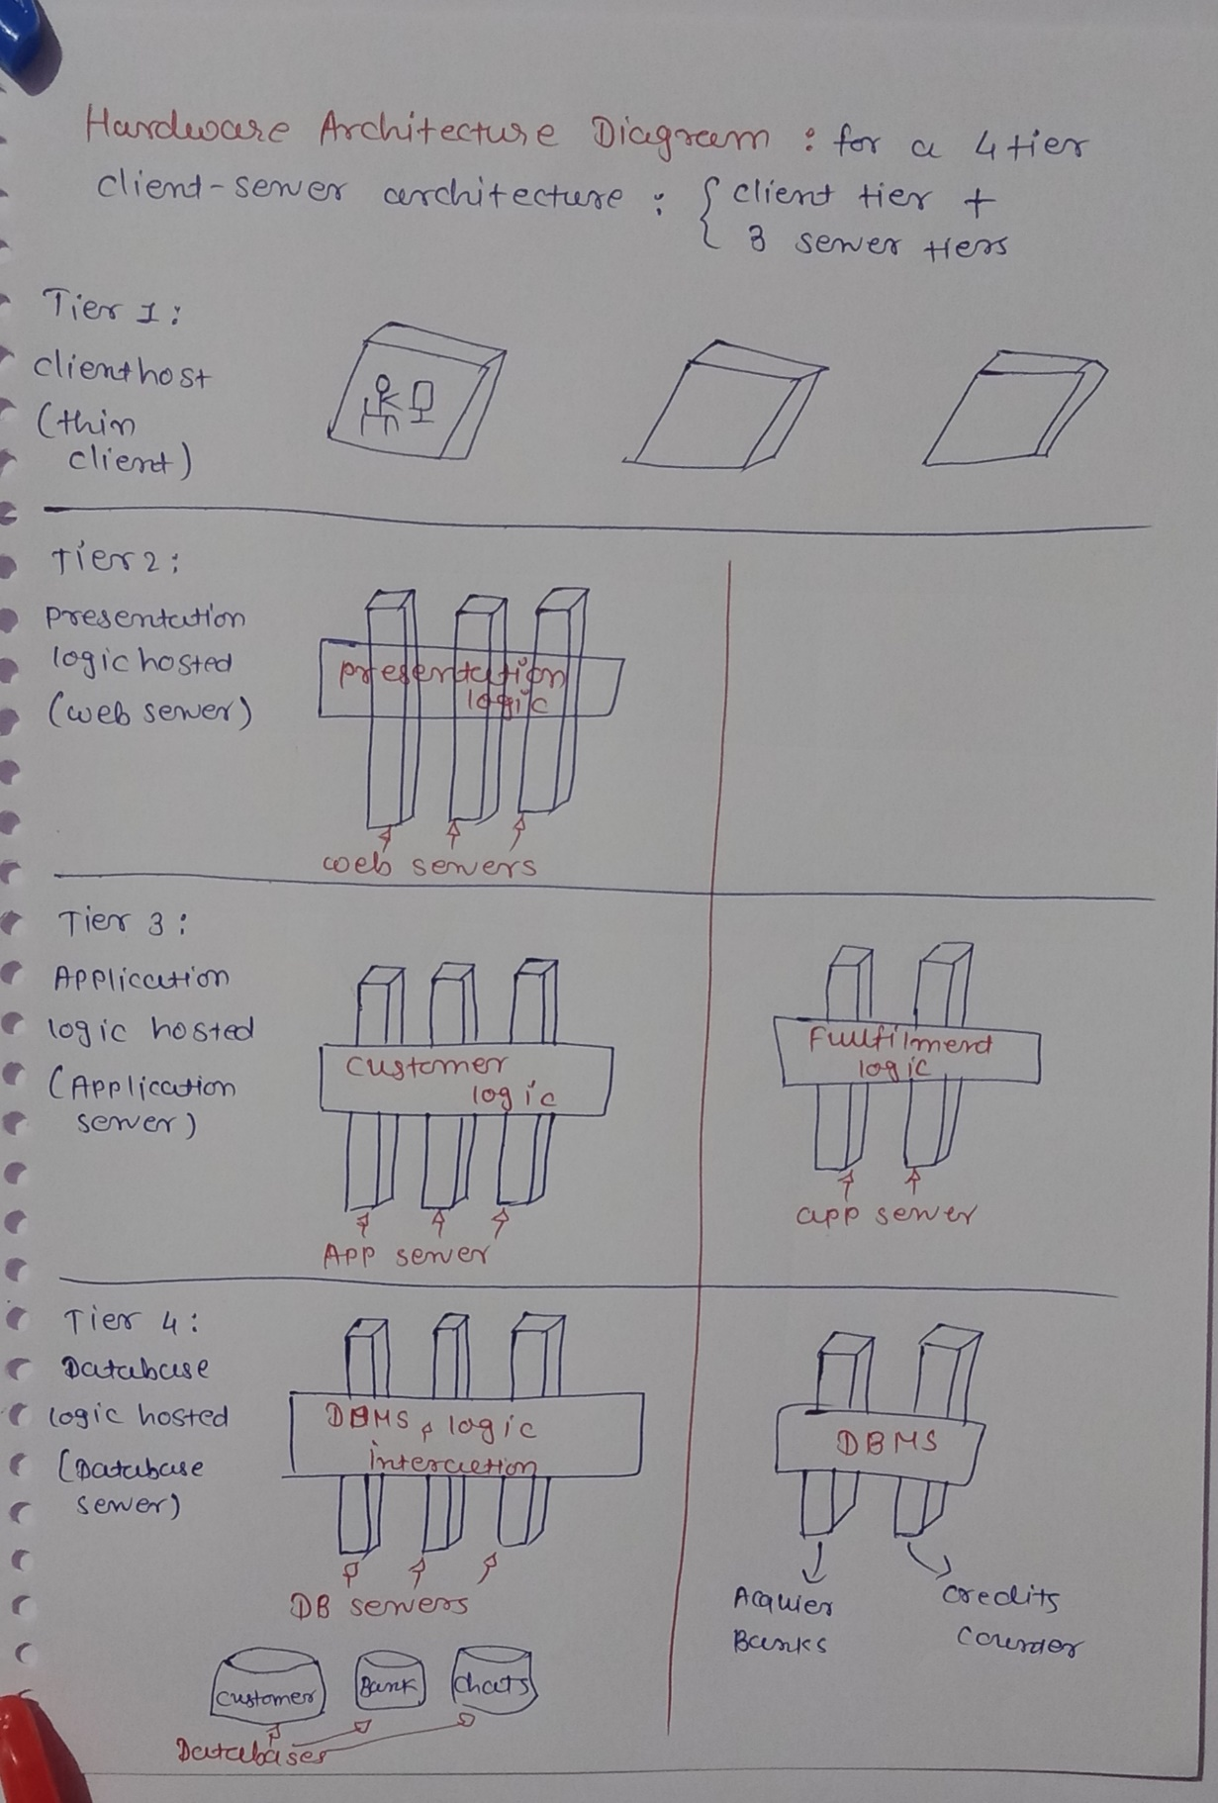

# Main Functionality

* **User authentication :** 
  + User can register with name, email, password
  + Password is hashed using bcrypt
  + JWT token generated during login
  + Authenticated routes are protected using middleware
* **Chat system :** 
  + Users can create chats
  + Chats include messages between user and AI
  + Chat name can be edited
  + Chat can be deleted anytime
  + Messages are stored in mongoDB
* **AI Text generation :** 
  + Users can send prompts
  + System calls AI API
  + Returns response
  + 1 credit deducted for each request
* **AI Image generation :** 
  + Users can generate images using AI
  + 2 credits per image generation
  + Generated images can be published in community gallery
* **Credit purchase system :** 
  + Users can buy credits via stripe
  + Plans include predefined credit amounts
  + Stripe checkout session is created and user is redirected
  + Successful payments are confirmed via webhook
  + Corresponding credits added into user’s account
* **Community Page :** 
  + All users can view AI-generated community images
  + Each post shows image + user details + prompt
* **Third-Party API integration for random jokes :** 
  + A random joke is fetched from Official joke API
  + Showcased in demo pages

# API Documentation [overview]

# Auth

|  |  |  |
| --- | --- | --- |
| Method | Endpoint | Description |
| POST | /api/users/register | Register user |
| POST | /api/users/login | Login user |
| GET | /api/users/me | Get logged in user |

# Chat

|  |  |  |
| --- | --- | --- |
| Method | Endpoint | Description |
| GET | /api/chats | List all chats |
| POST | /api/chats | Create chat |
| GET | /api/chats/:id | Get chat |
| PUT | /api/chats/:id | Update chat |
| DELETE | /api/chats/:id | Delete chat |

# AI answer generation

|  |  |  |
| --- | --- | --- |
| Method | Endpoint | Description |
| POST | /api/messages/text | Text generation |
| POST | /api/messages/image | Image generation |

# Credits

|  |  |  |
| --- | --- | --- |
| Method | Endpoint | Description |
| GET | /api/credits/plans | Plans list |
| POST | /api/credits/purchase | Stripe session |
| GET | /api/ credits/me | User credits |
| GET | /api/ credits/transactions | Transactions |
| PATCH | /api/ credits/transactions/:id | Update |

# Stripe

|  |  |  |
| --- | --- | --- |
| Method | Endpoint | Description |
| POST | /api/stripe/webhook | Raw webhook endpoint |

# Third-Party API

|  |  |  |
| --- | --- | --- |
| Method | Endpoint | Description |
| GET | /api/jokes/random | Generate random joke |

# System Snapshots

***[01] running backend***

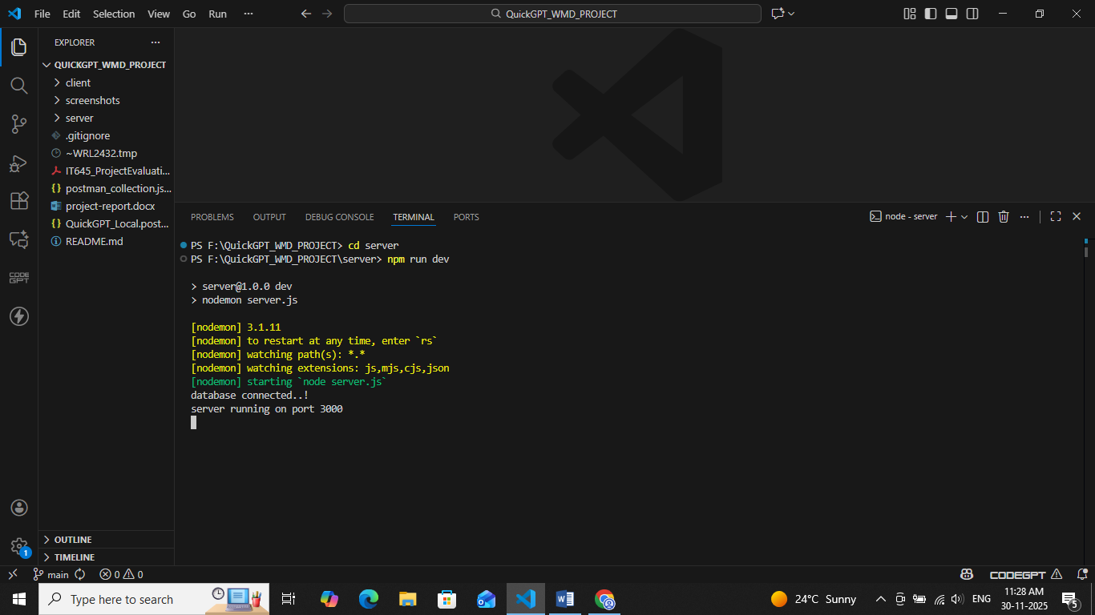

***[02] server-side rendering using EJS template engine***

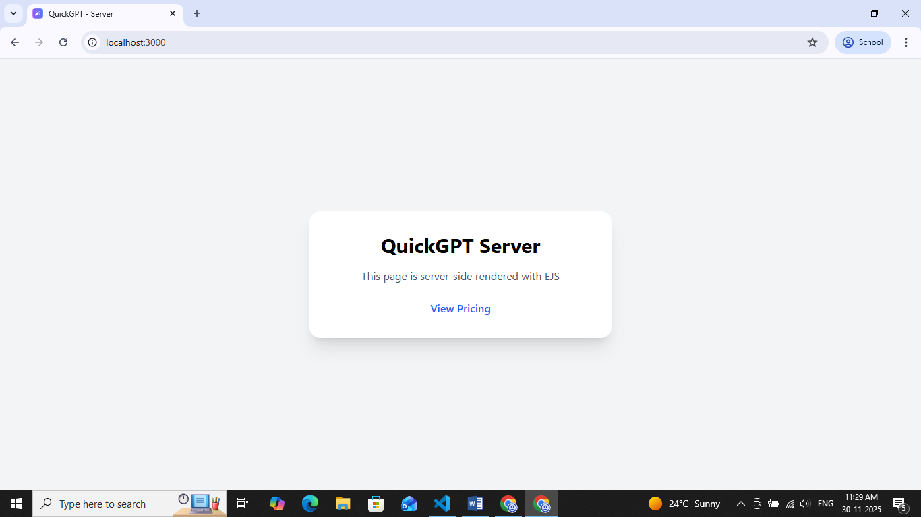

***[03] server-side rendering pricing page***

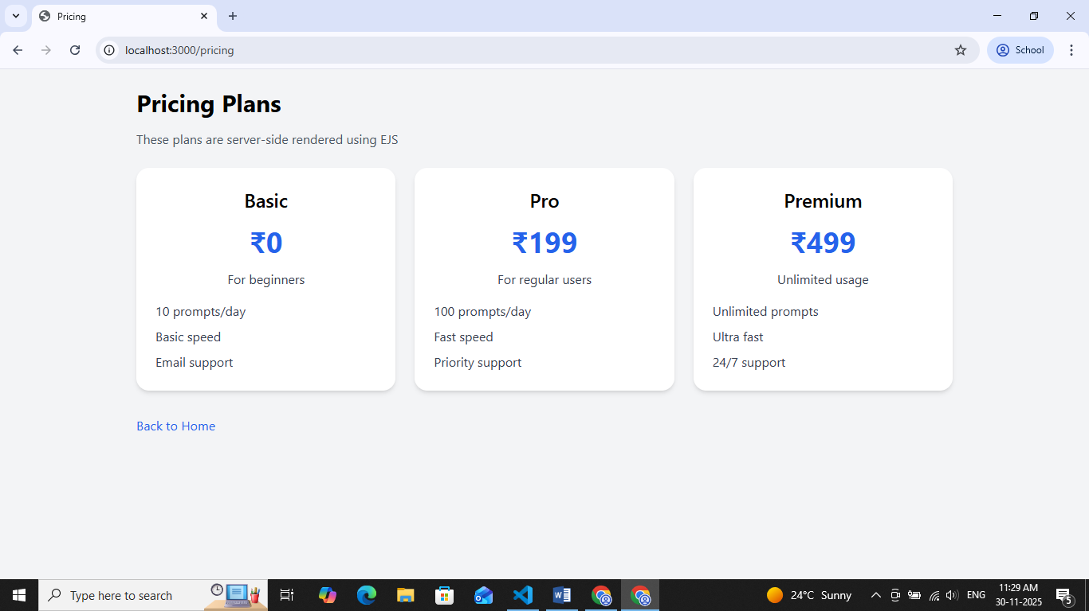

***[04] logs***

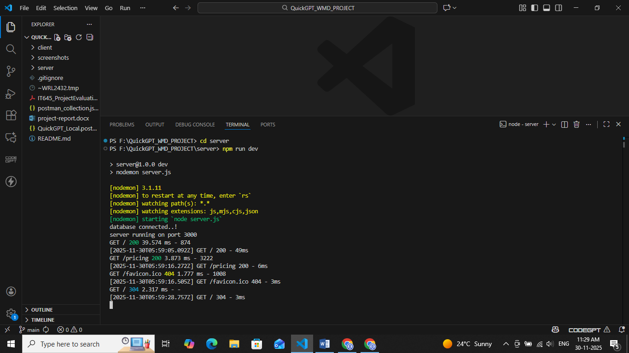

***[05] running frontend***

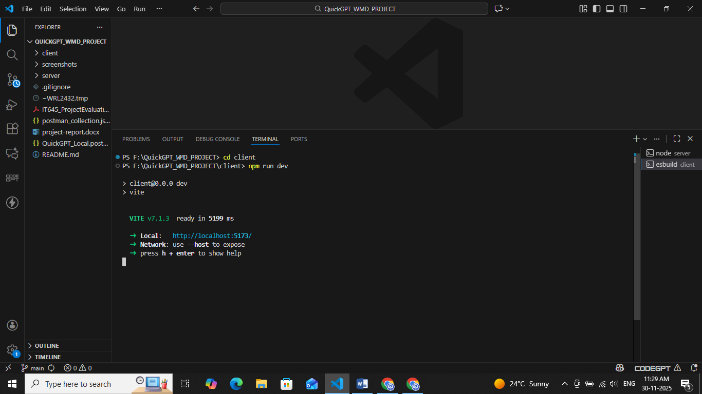

***[06] registration page***

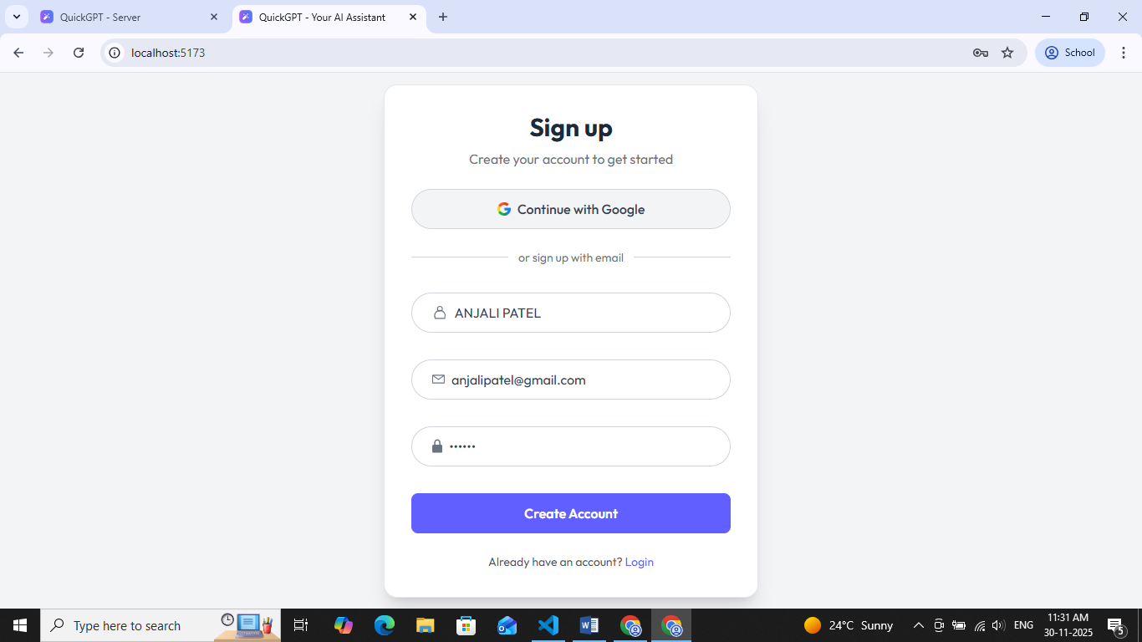

***[07] login page***

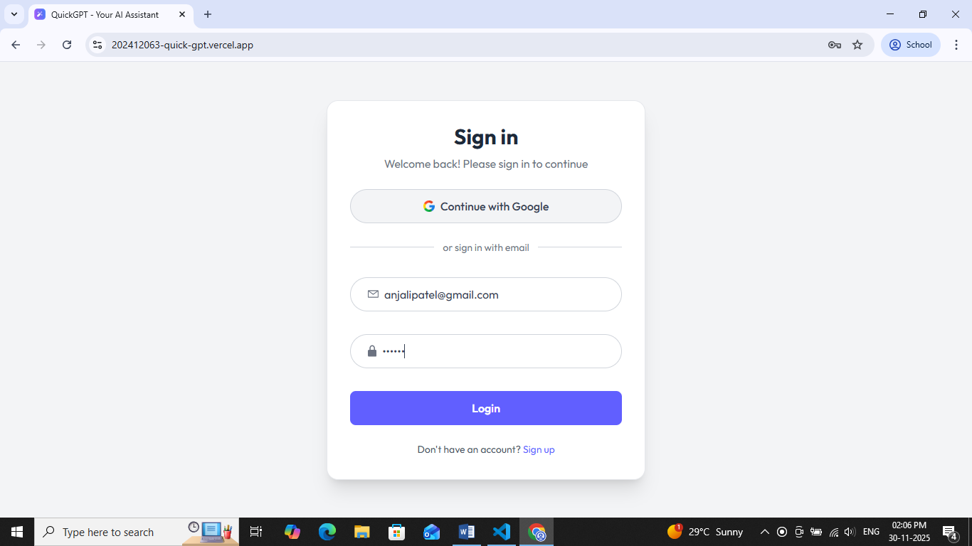

***[08] home page***

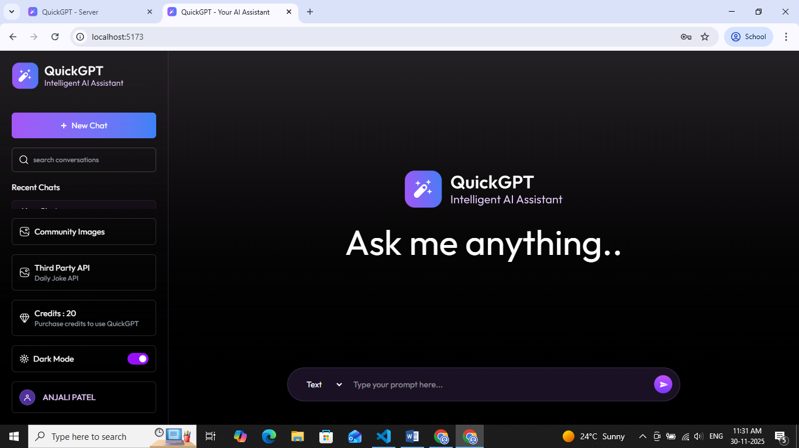

***[09] home page in light mode***

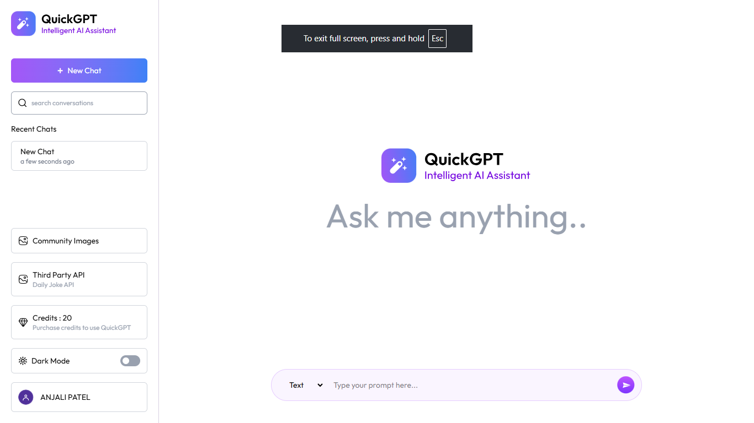

***[10] text message prompt***

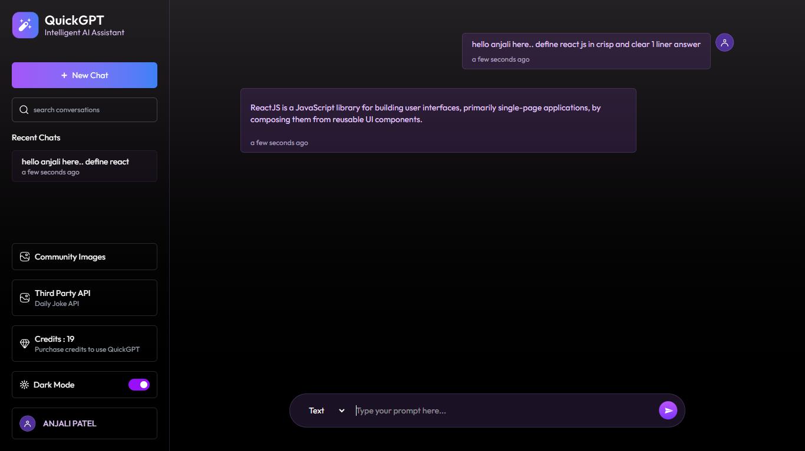

***[11] image generation prompt and adding image to community***

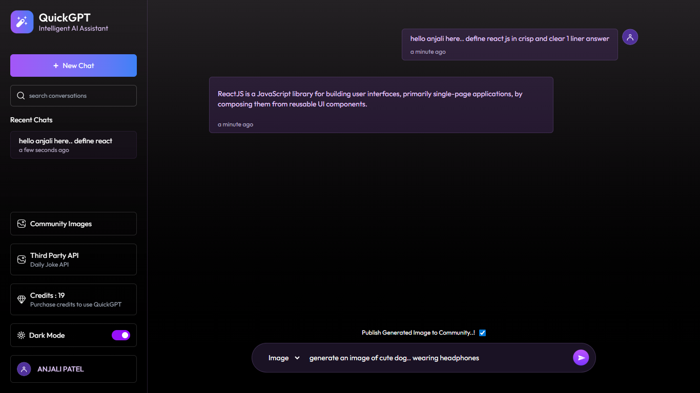

***[12] image generated***

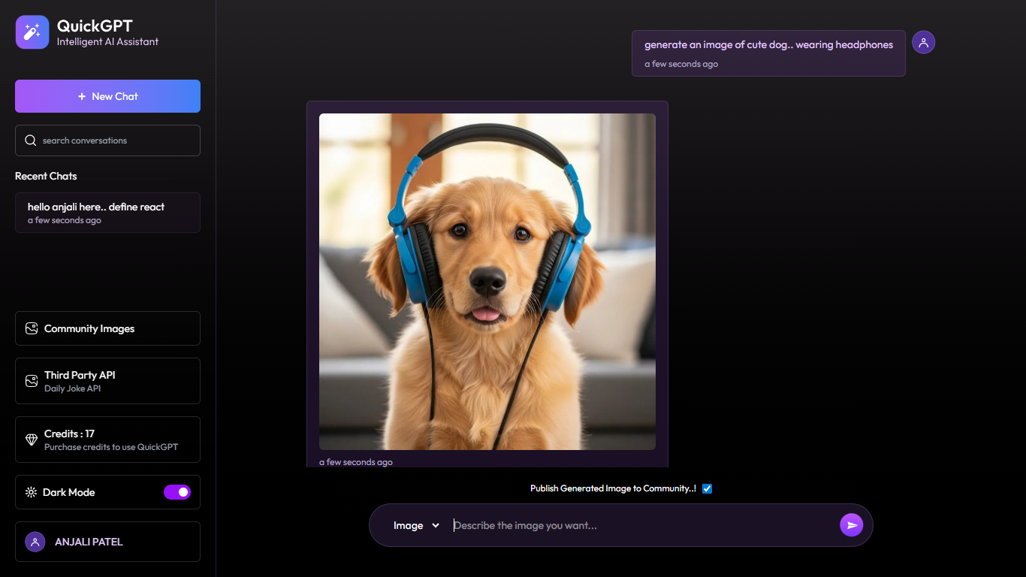

***[13] community images***

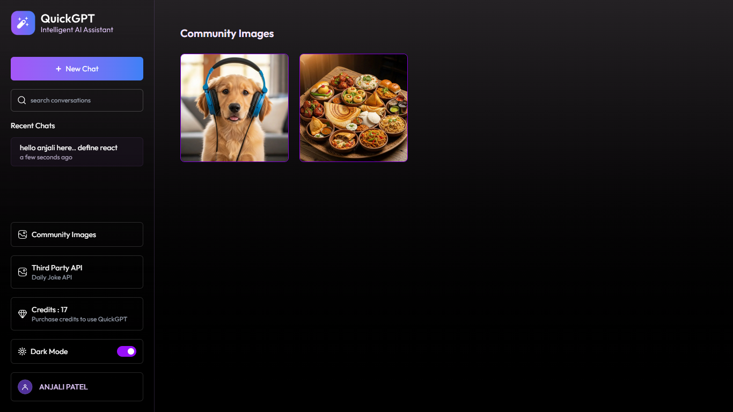

***[14] pre-defined credit plans***

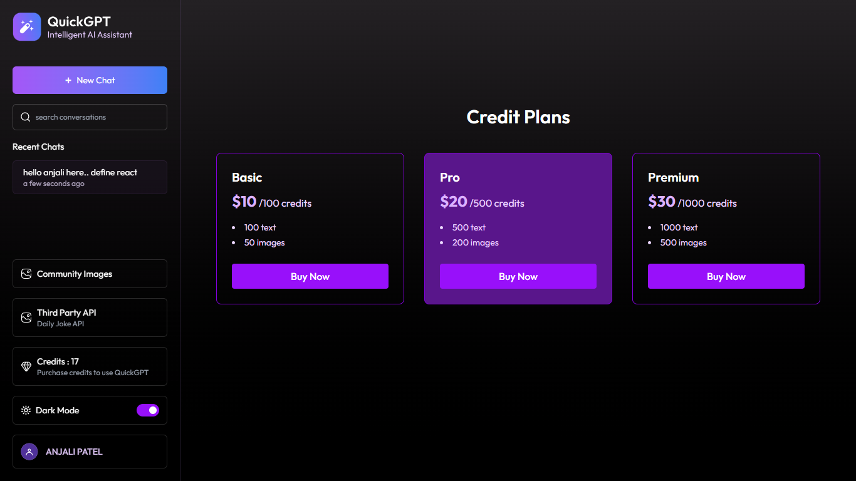

***[15] initiate payment***

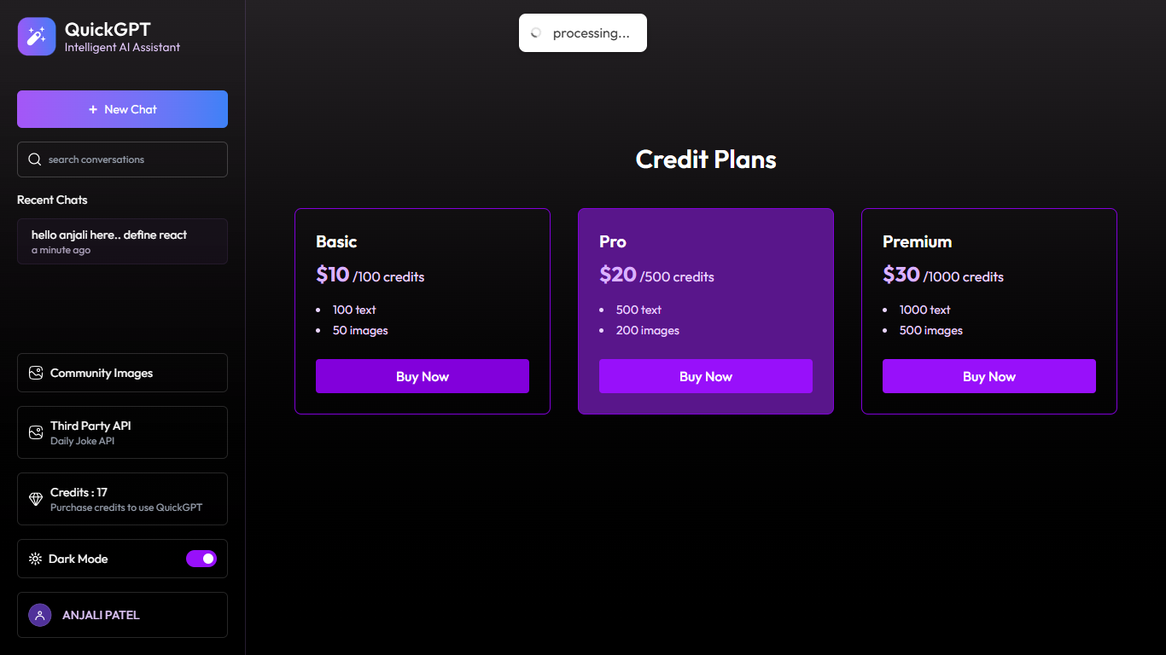

***[16] stripe payment page with dummy details***

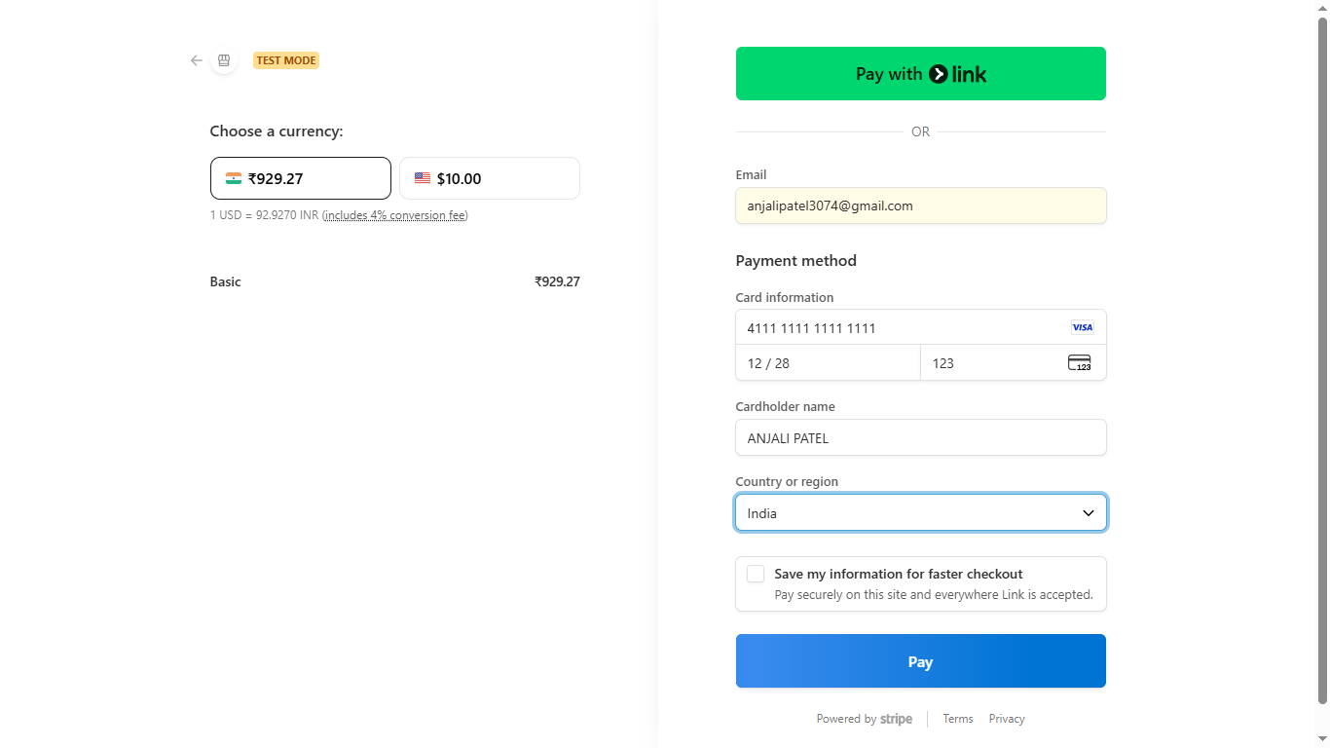

***[17] payment successful***

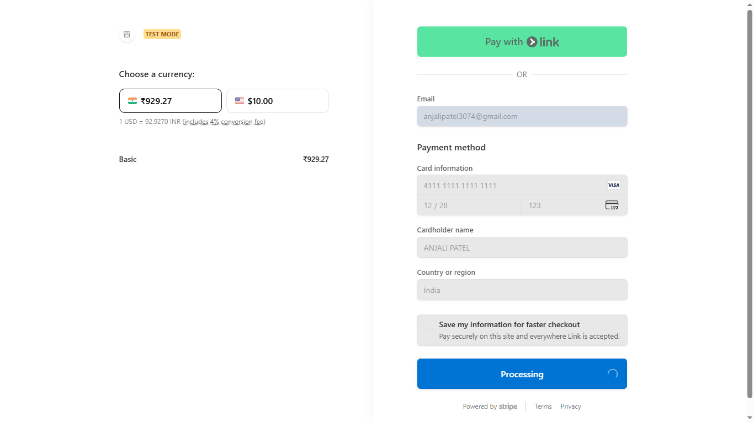

***[18] redirection***



***[19] updated credits***

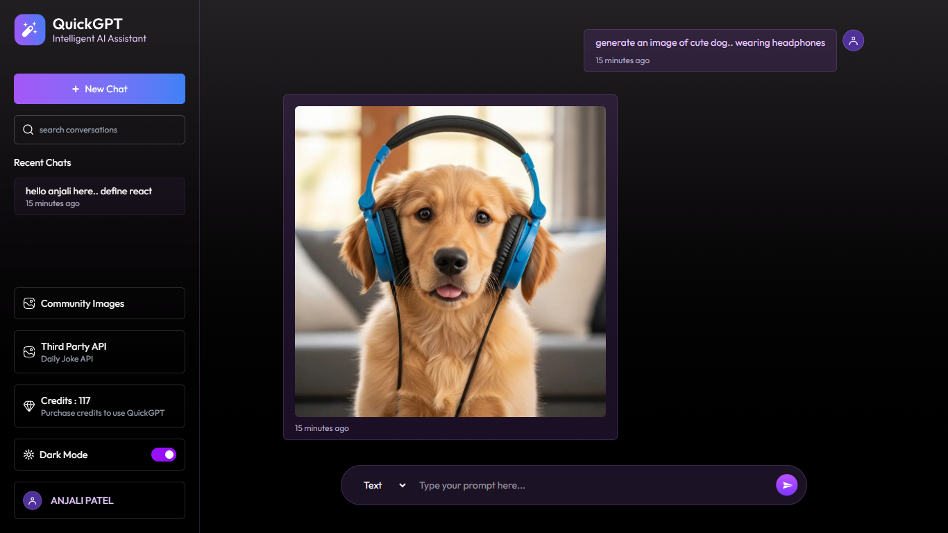

***[20] new chat creation***

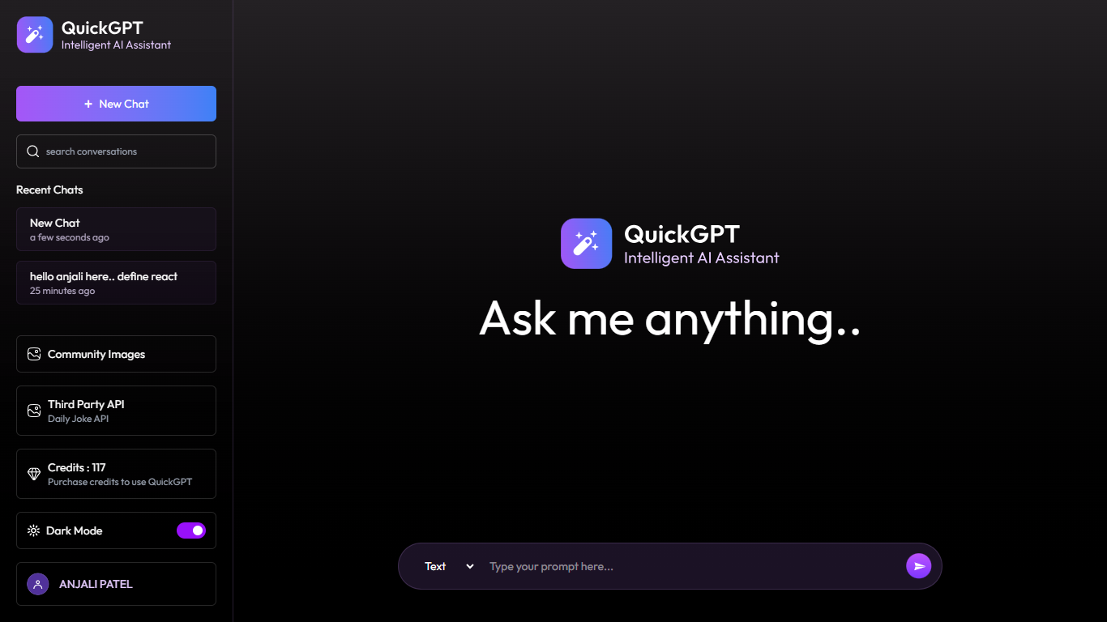

***[21] delete chat***

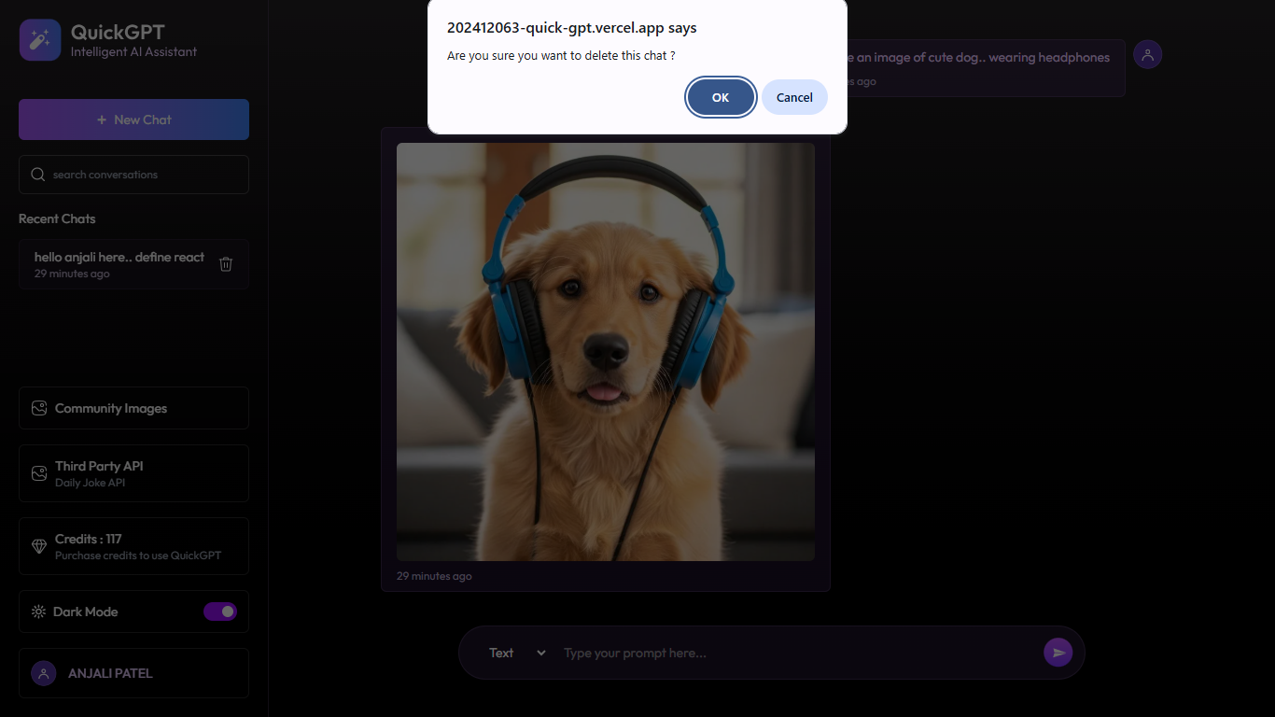

***[22] deleting***

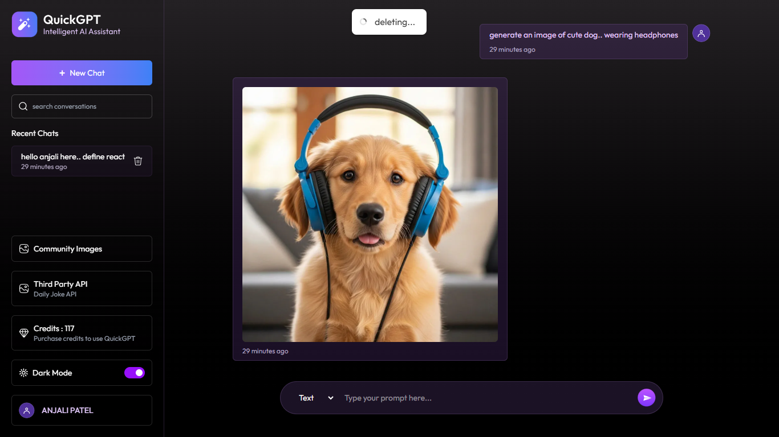

***[23] chat deleted***

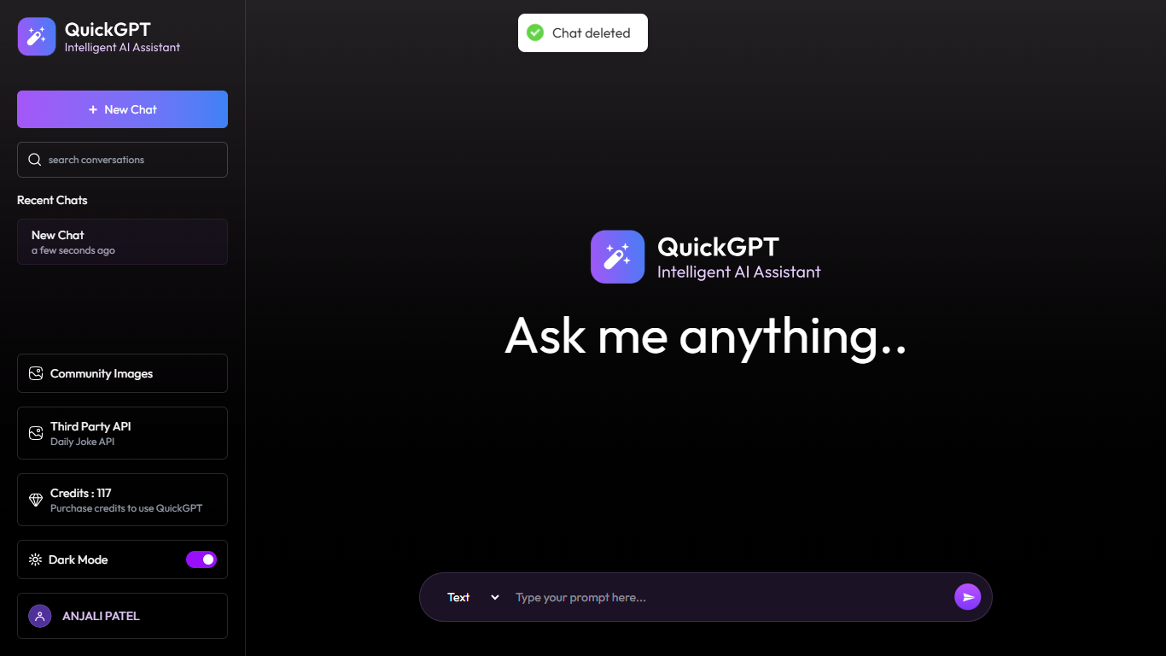

***[24] third-party API***

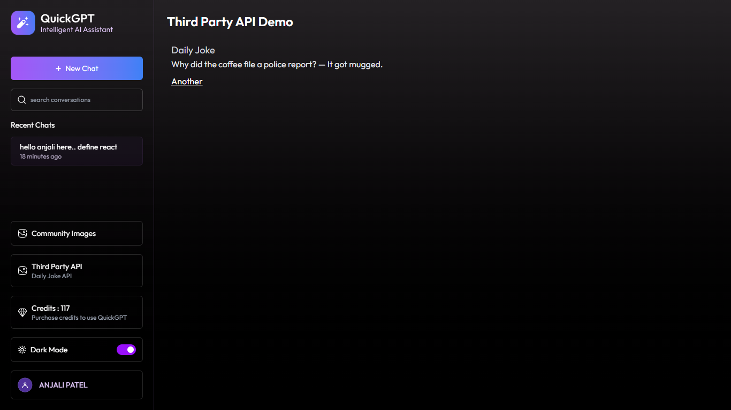

***[25] random joke generation***

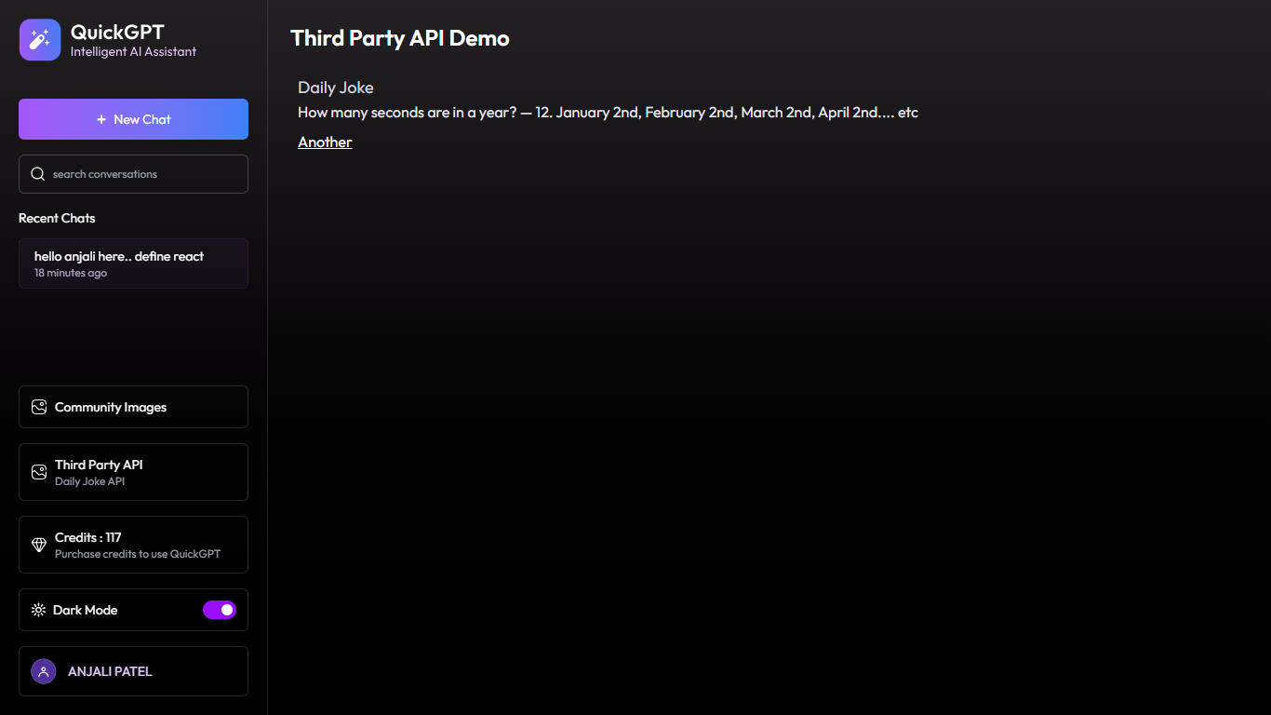

***[26] logout***

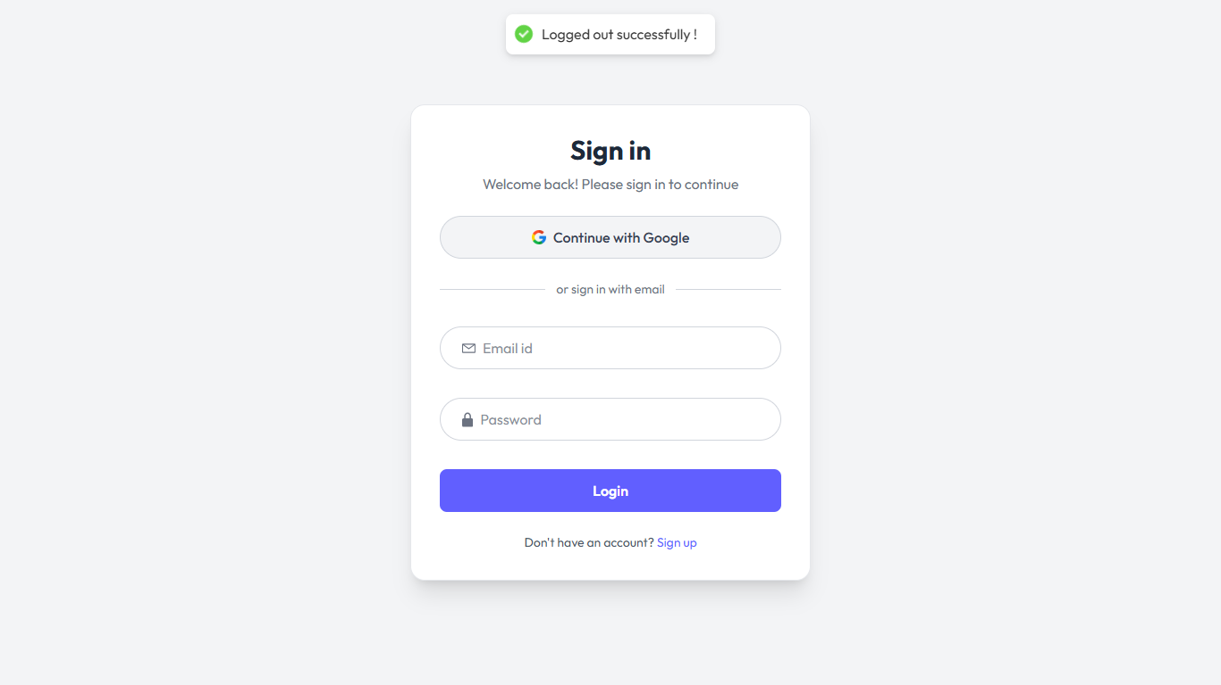

# Testing Snapshots

***[01] register user API***

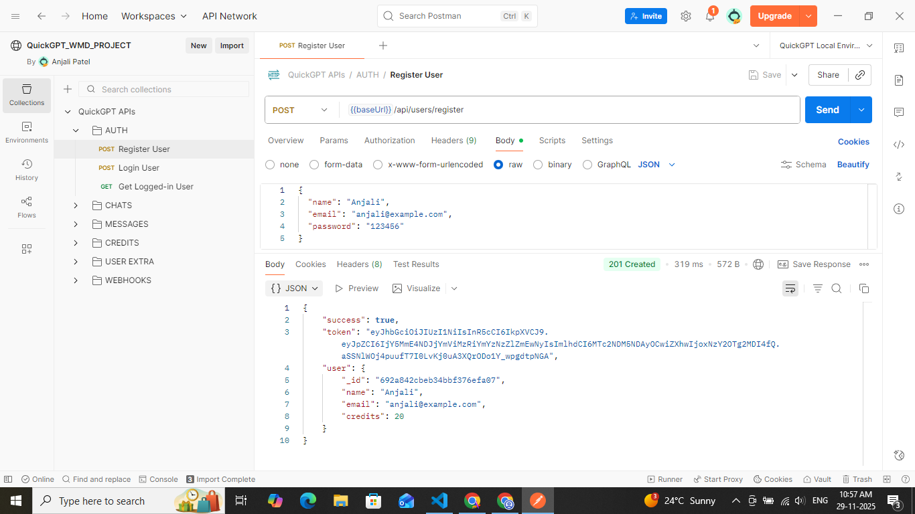

***[02] login user API***

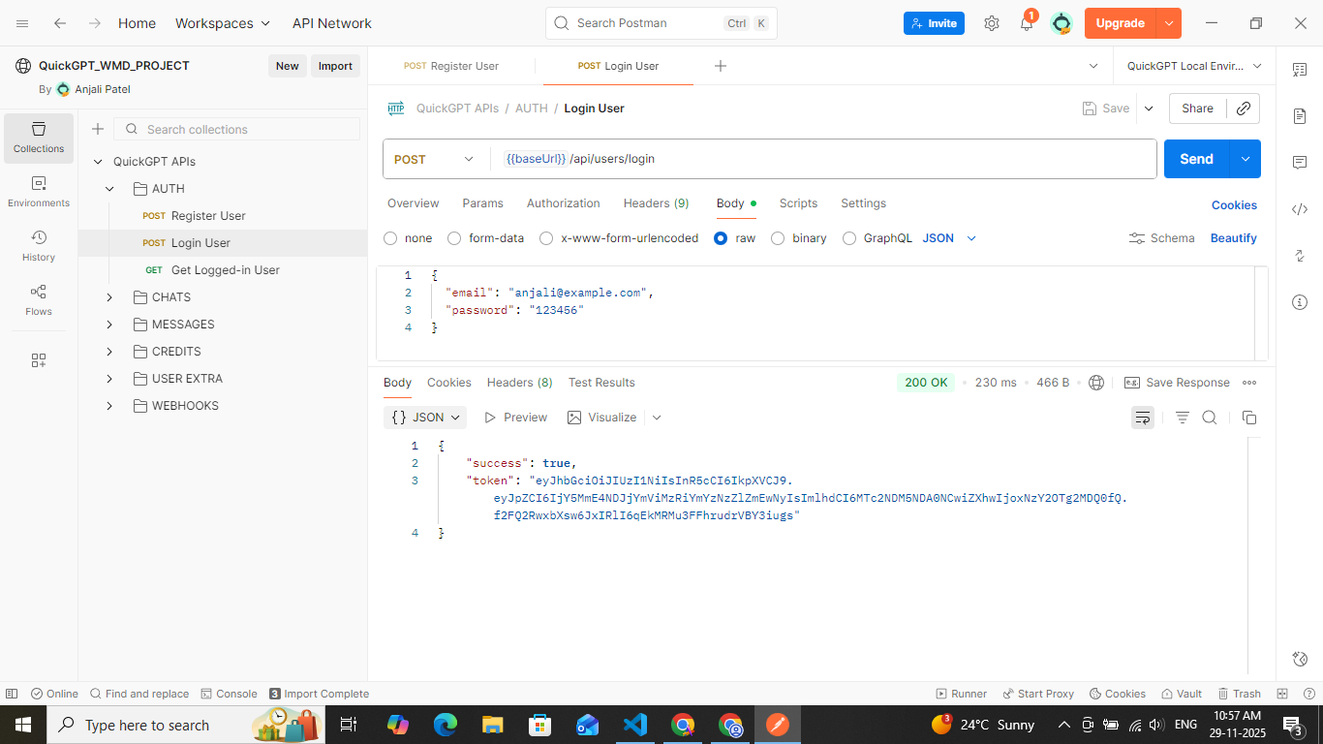

***[03] adding token to environment variable***

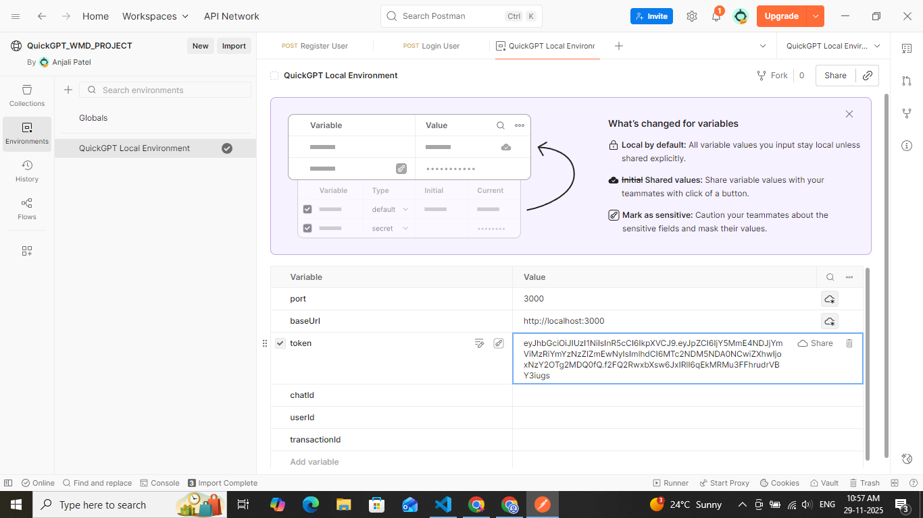

***[04] get logged-in user API***

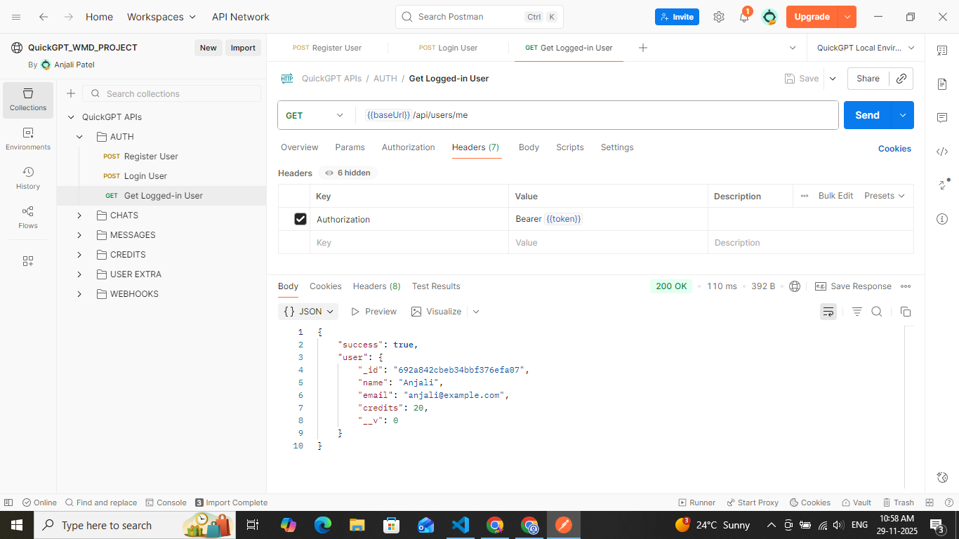

***[05] create chat API***

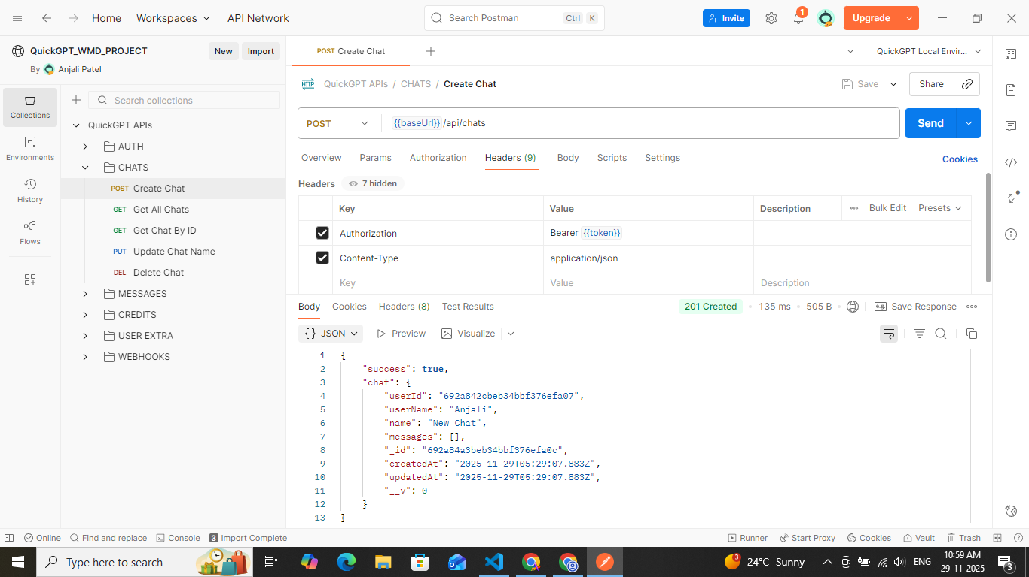

***[06] adding chatID-to environment variable***

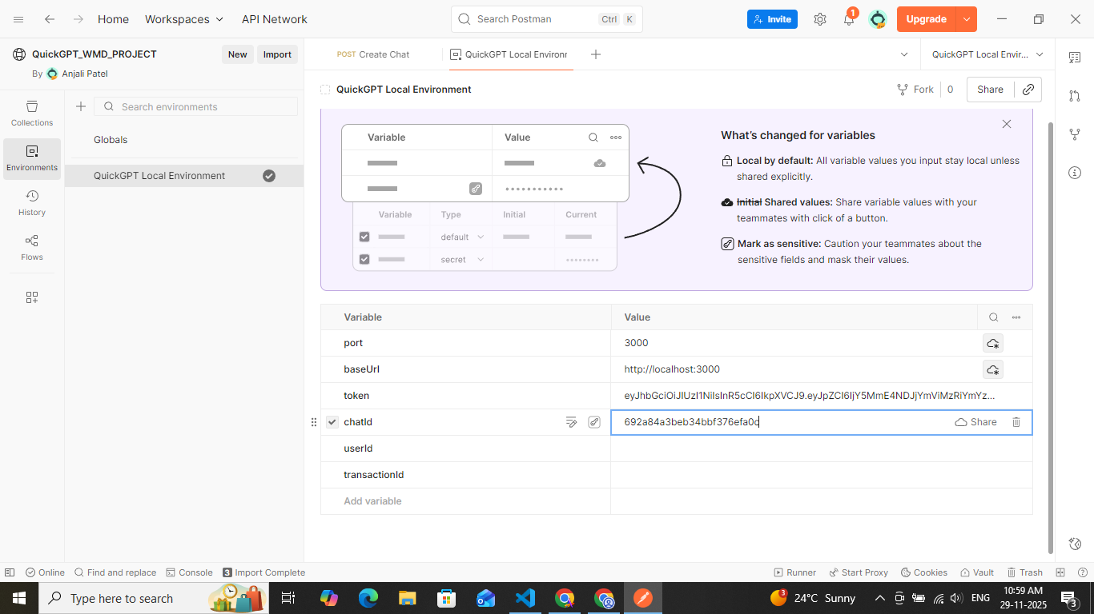

***[07] get all chats API***

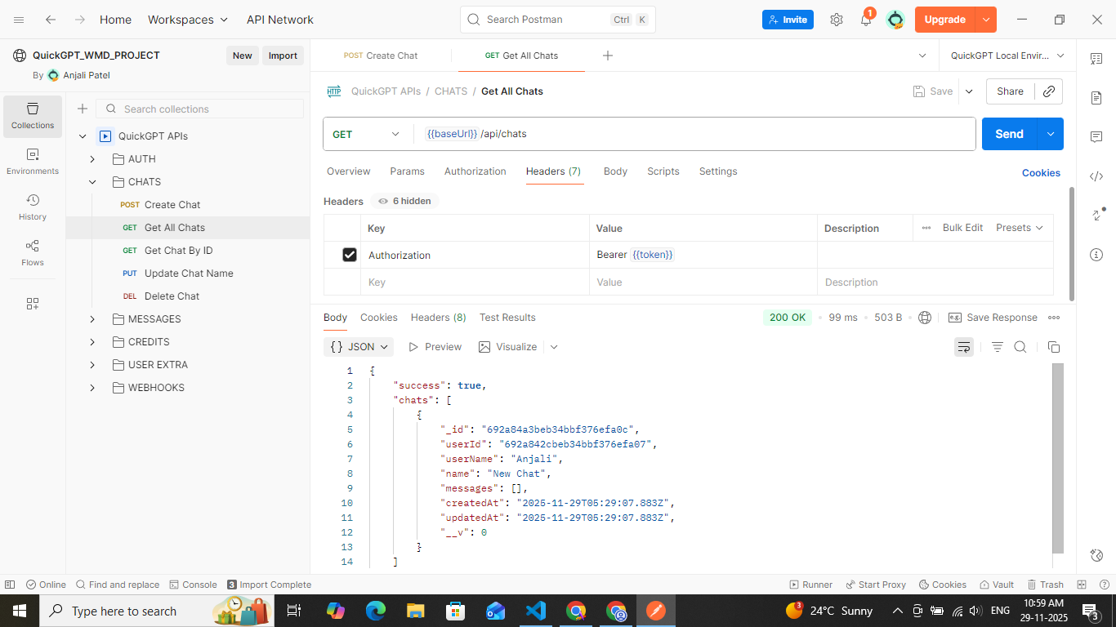

***[08] get chat by ID***

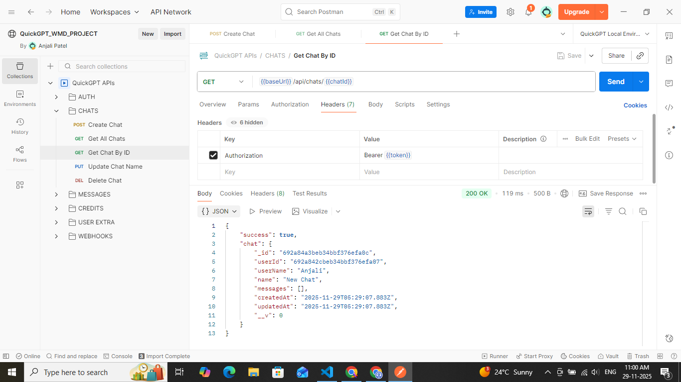

***[09] update chat name***

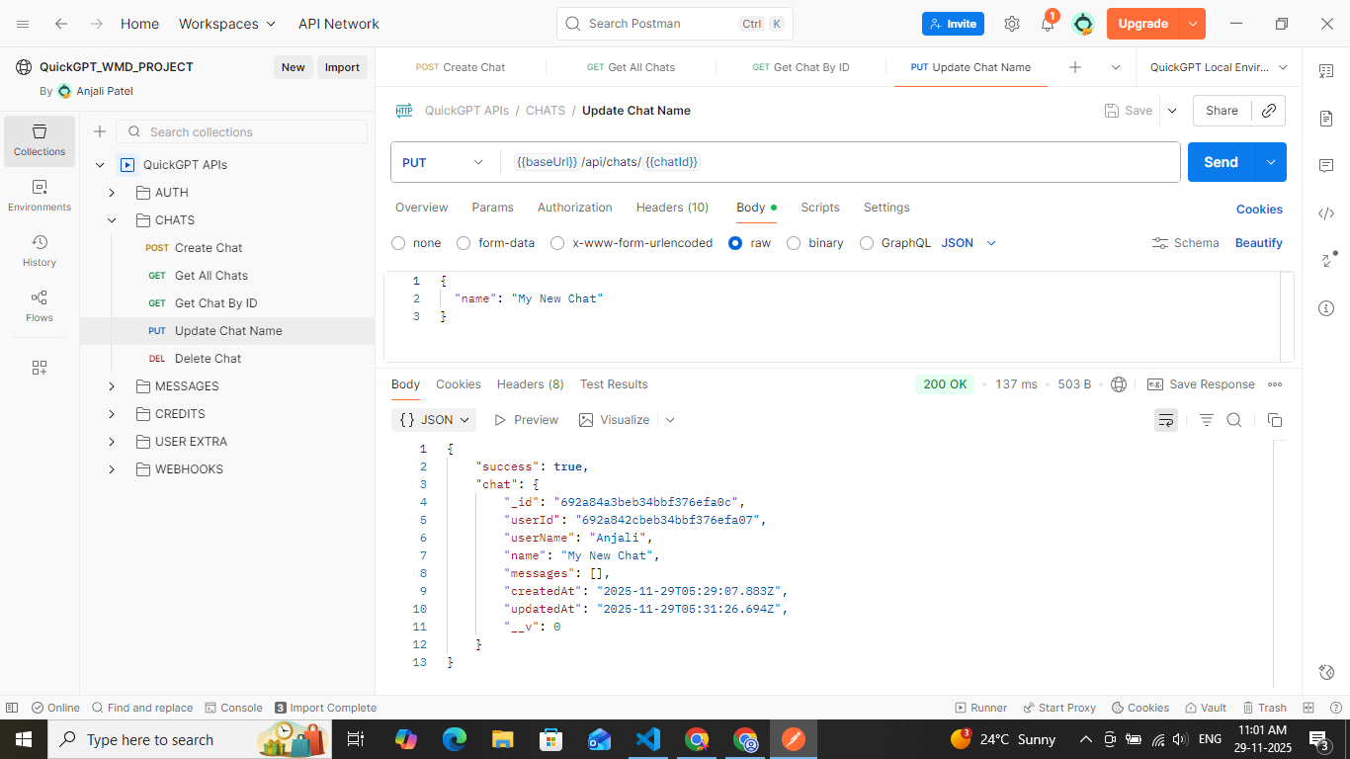

***[10] send text message***

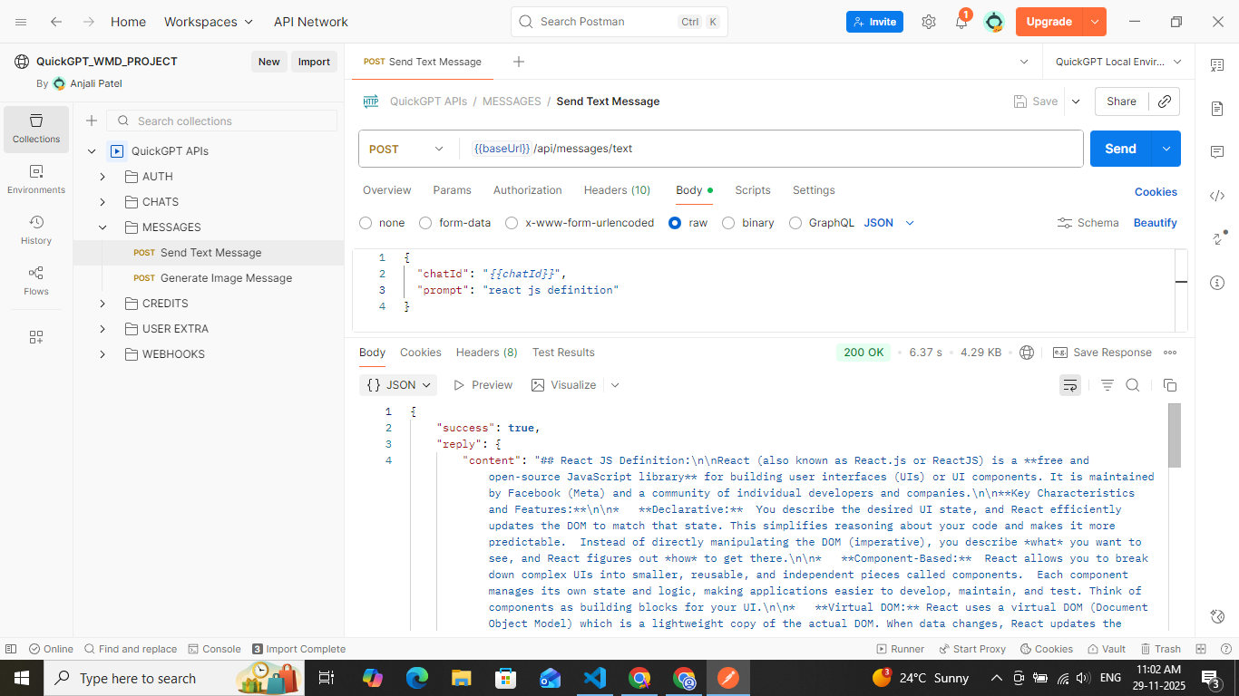

***[11] send text message API 2***

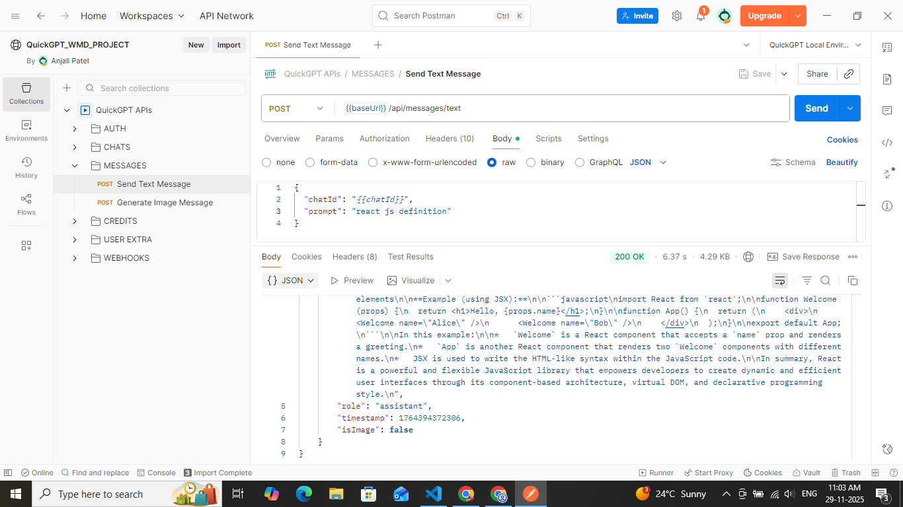

***[12] generate image message***

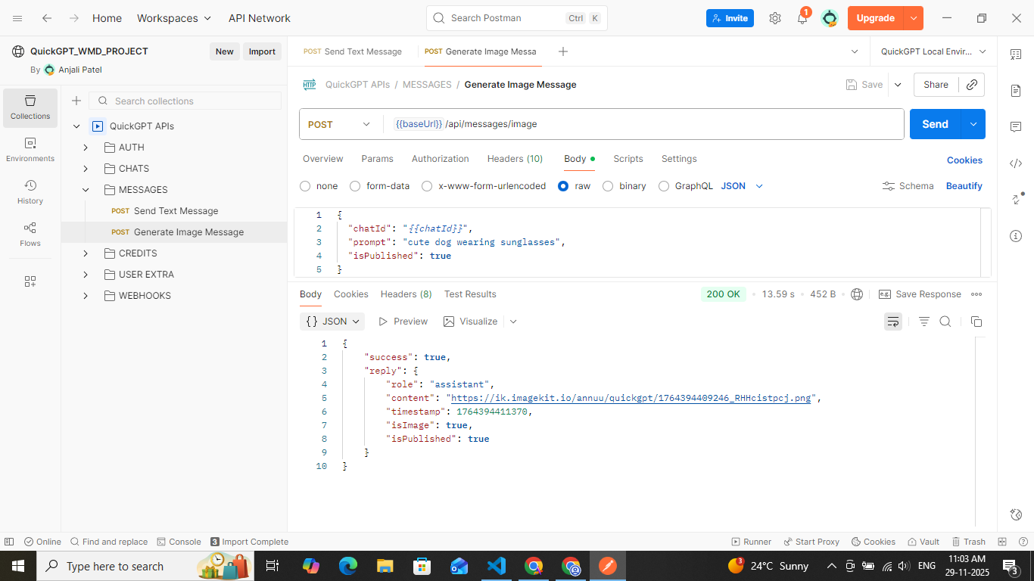

***[13] getting generated image from link***



***[14] delete chat API***

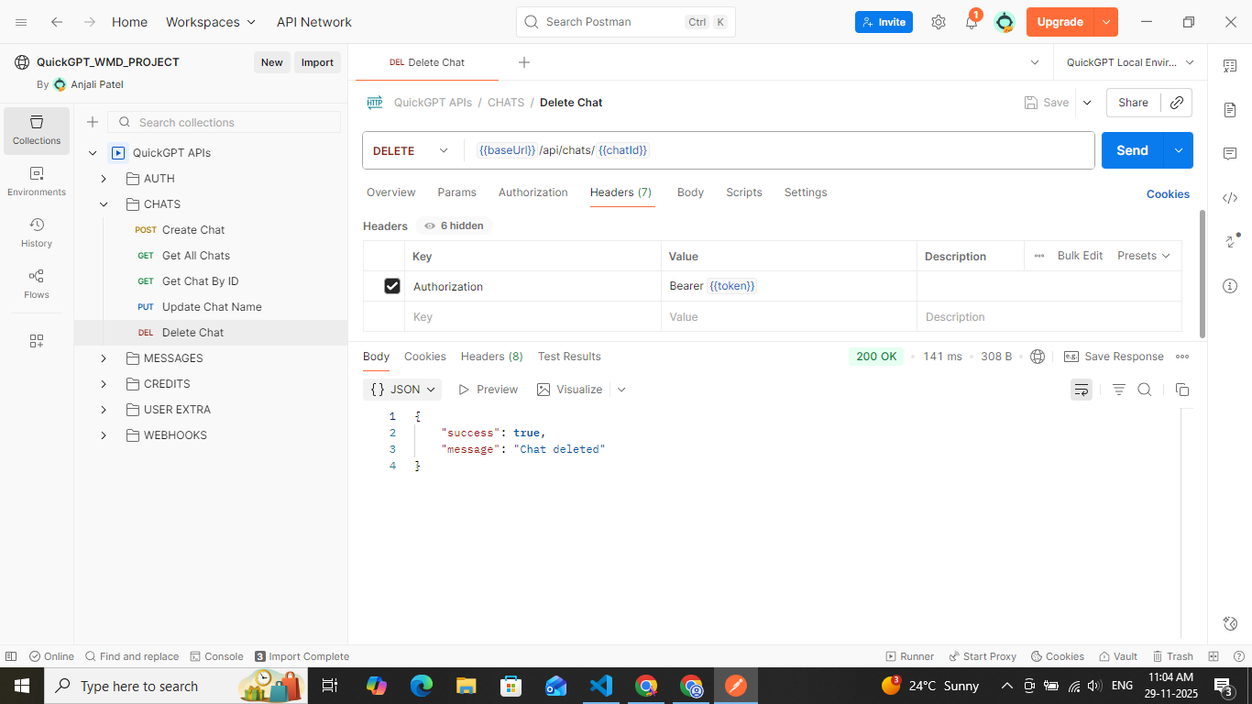

***[15] get plans API***

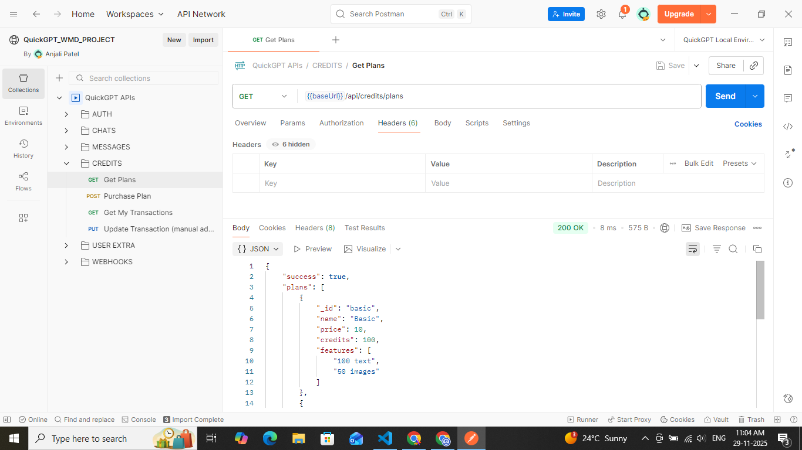

***[16] get plans API 2***

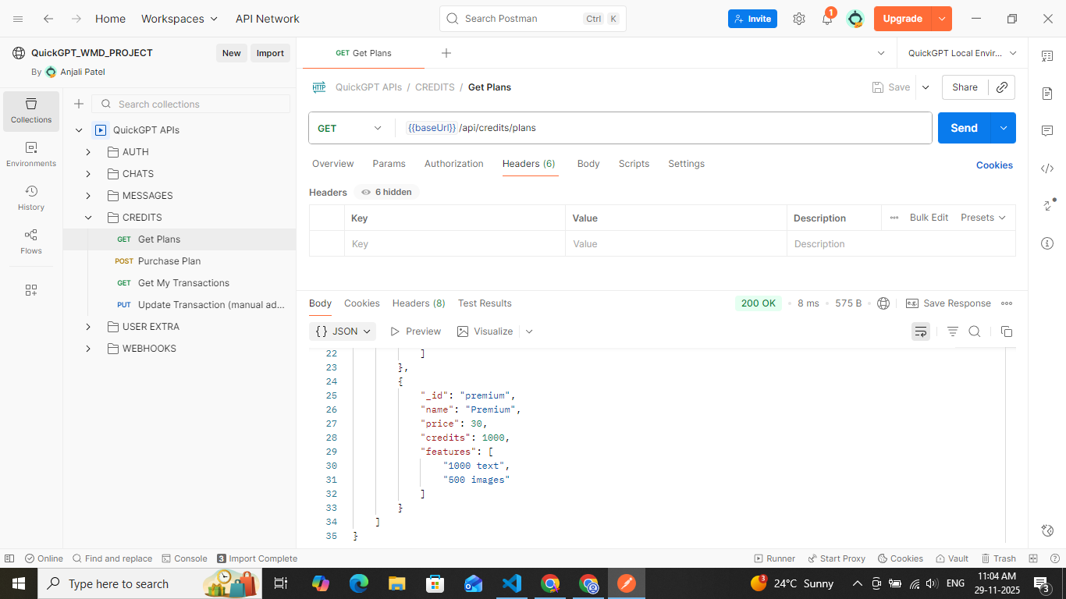

***[17] purchase plan***

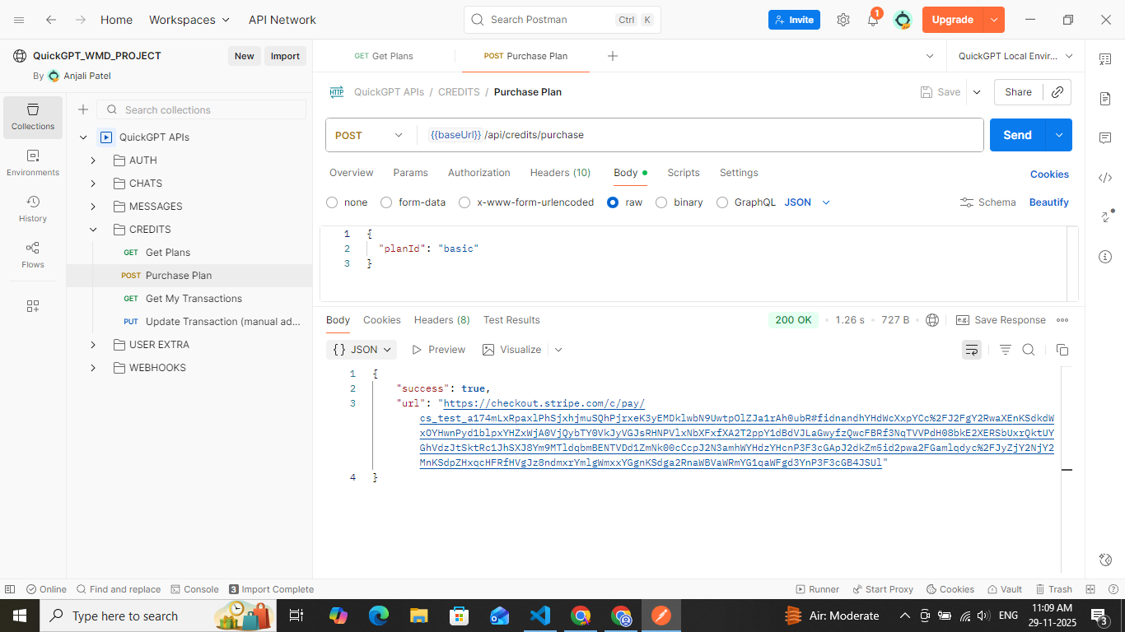

***[18] payment processing***

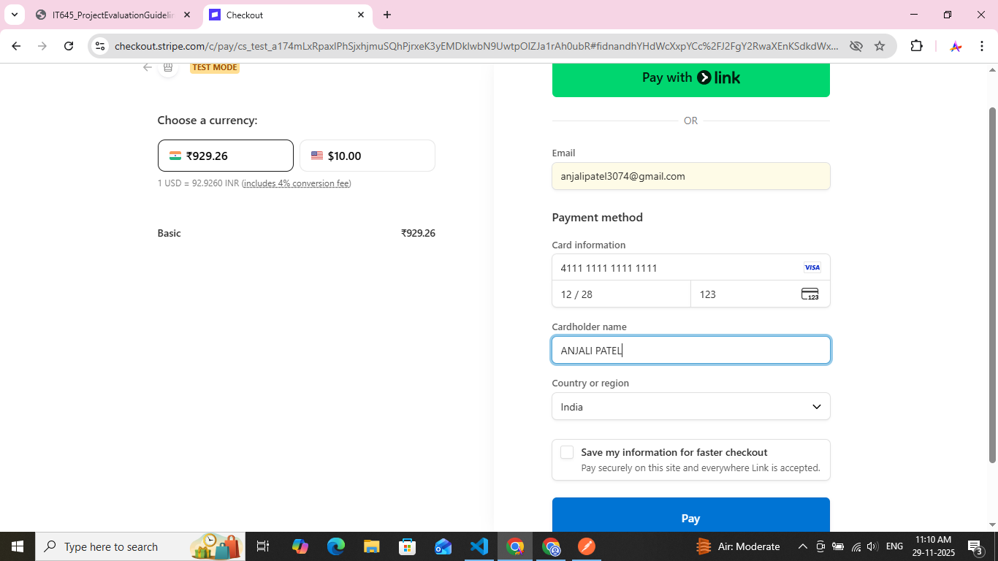

***[19] redirected after sucessful payment***

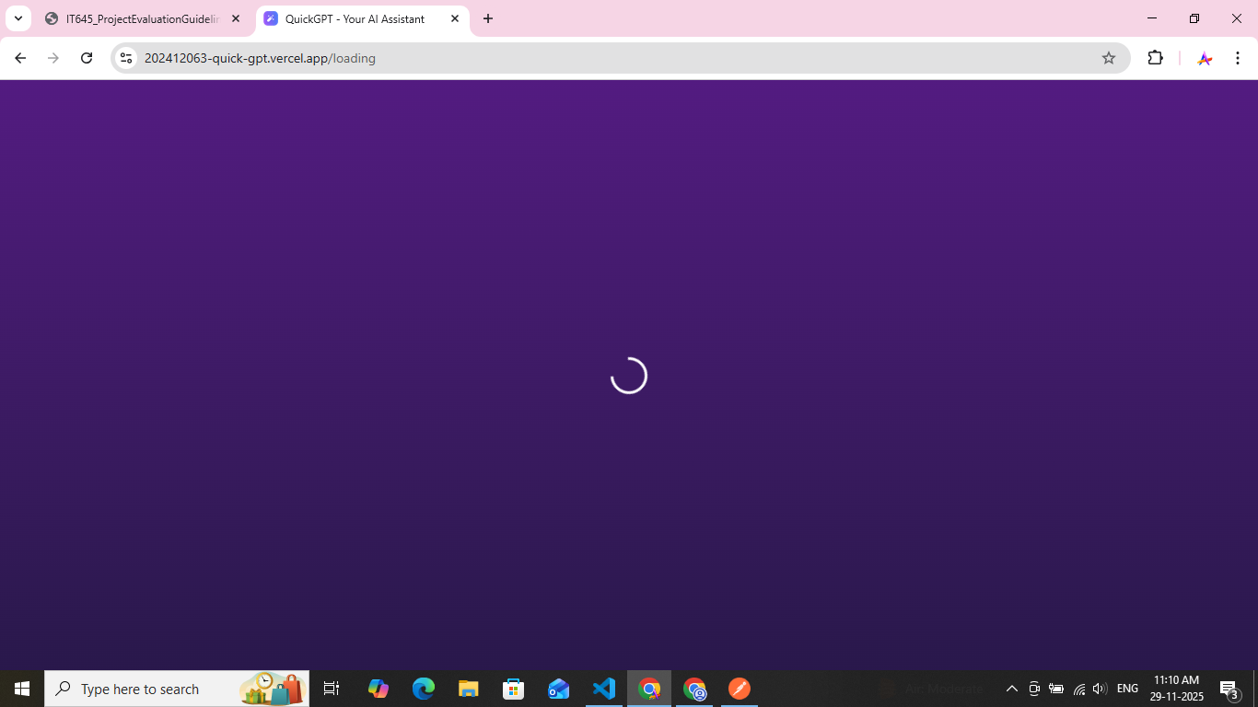

***[20] updated credits***

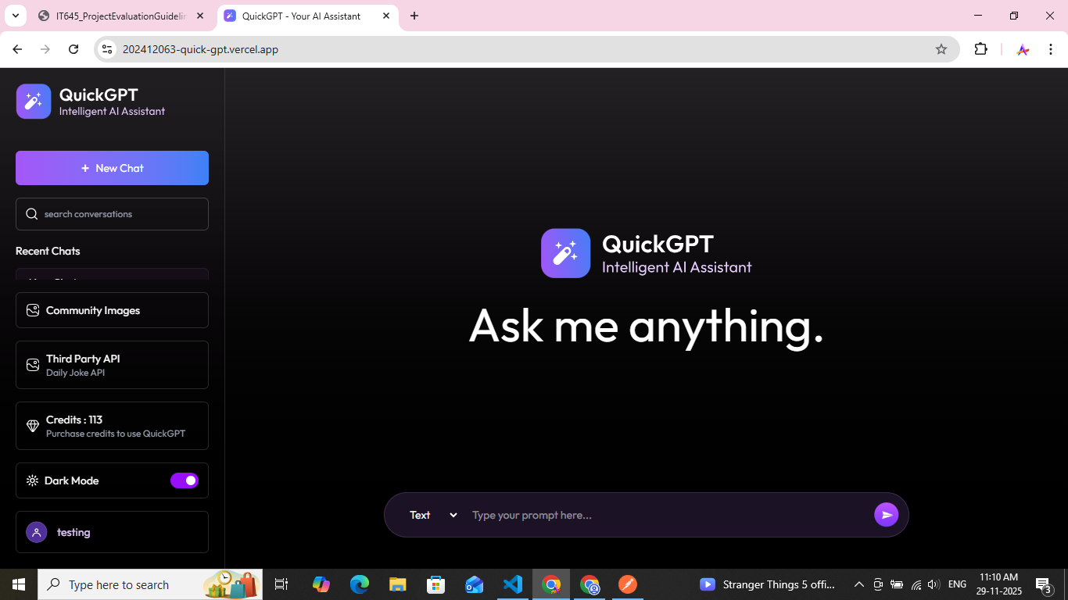

***[21] get my transactions API***

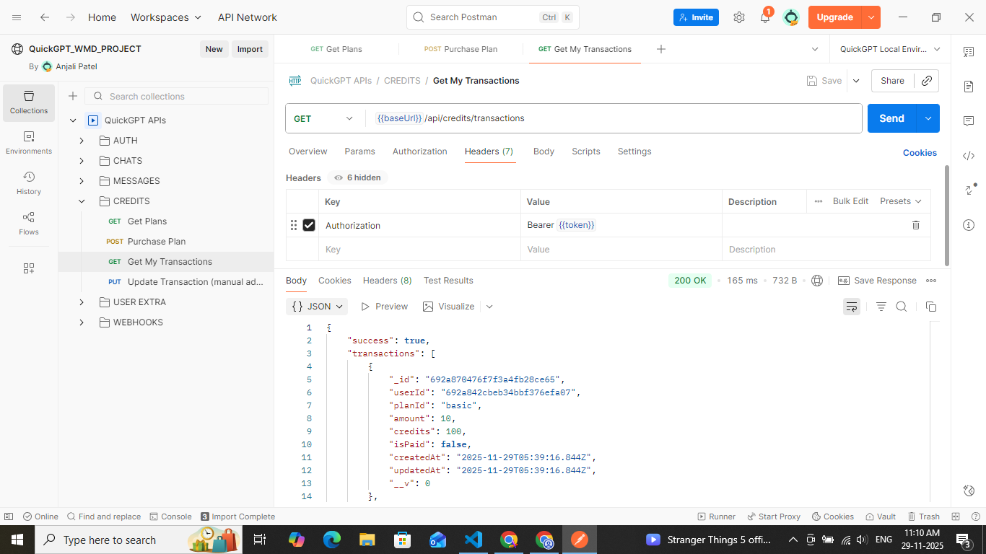

***[22] get credits of particular user API***

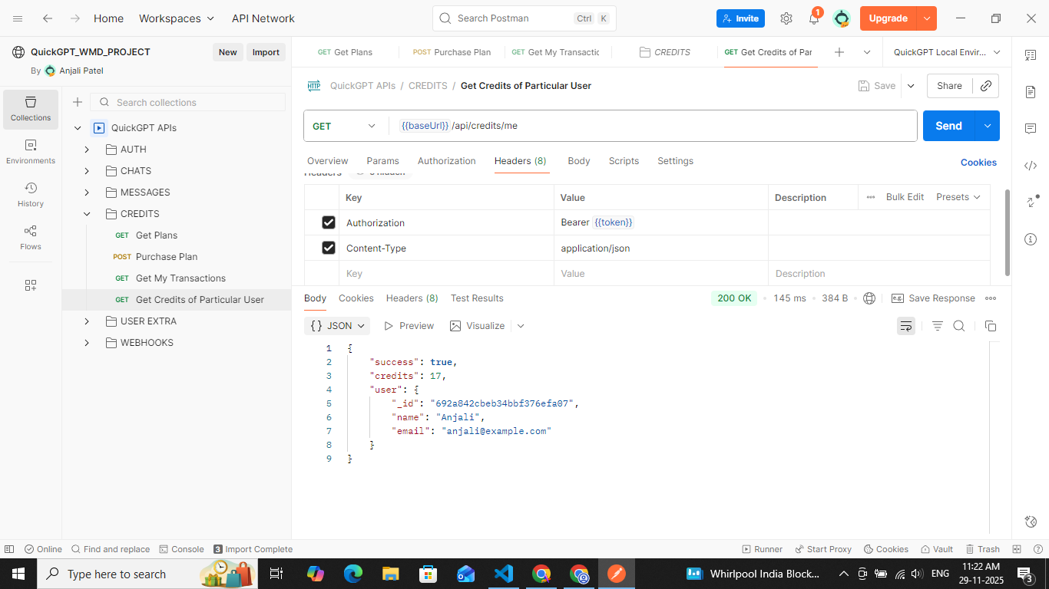

***[23] get user by ID API***

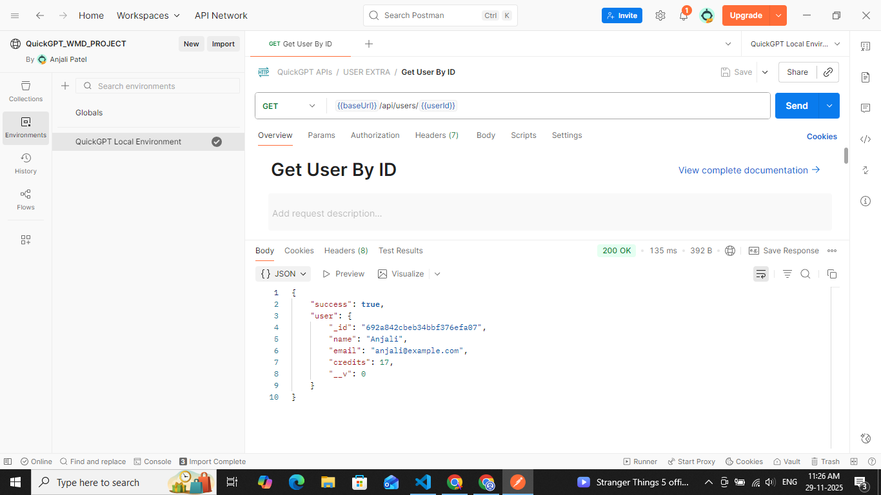

***[24] update user credits API***

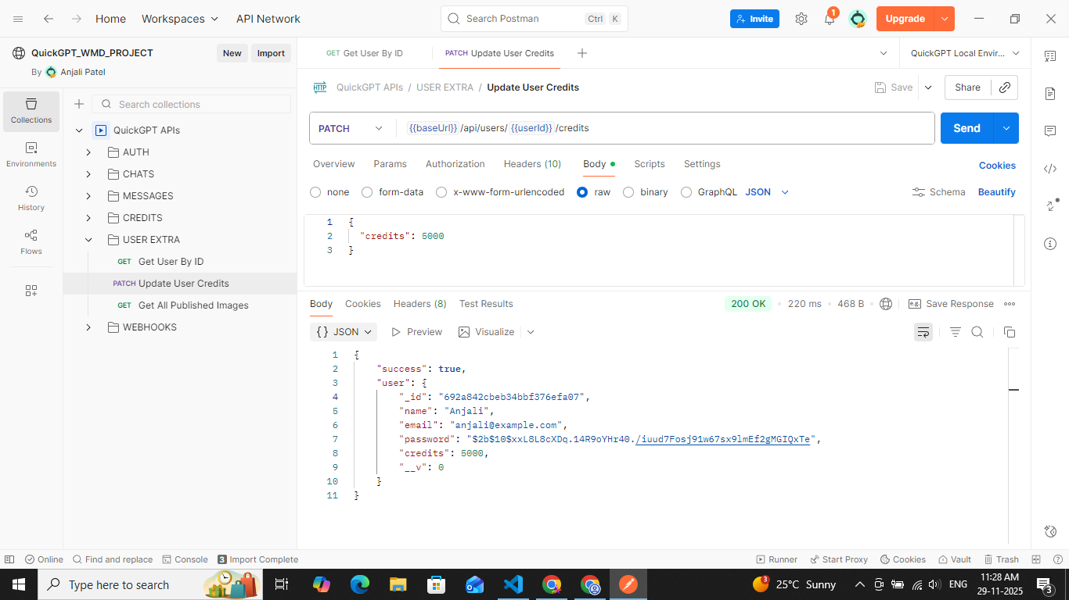

***[25] get all published images API***

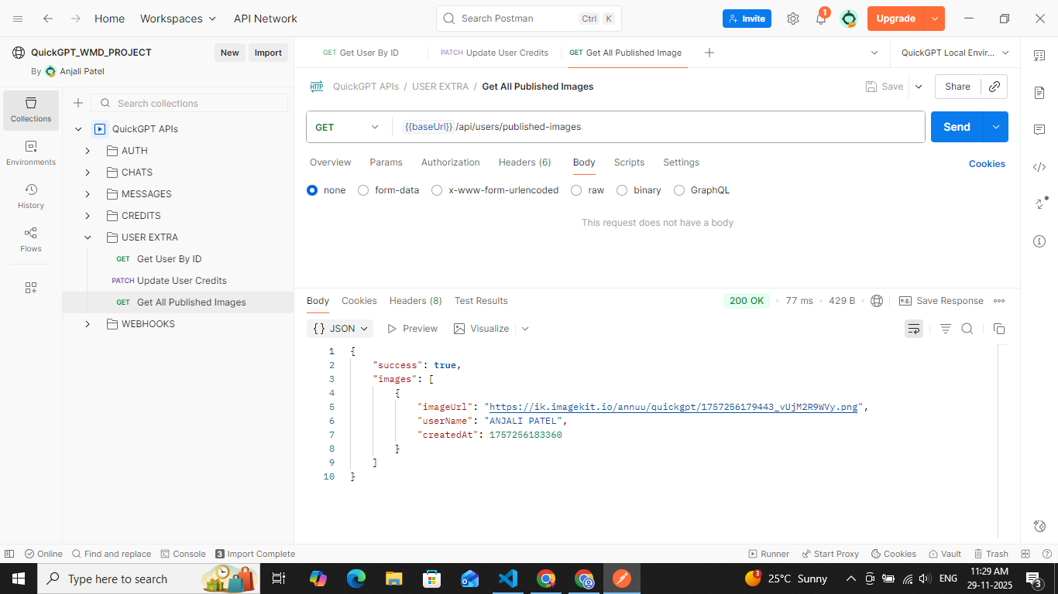

***[26] getting published image from link***



***[27] get random joke third party API***

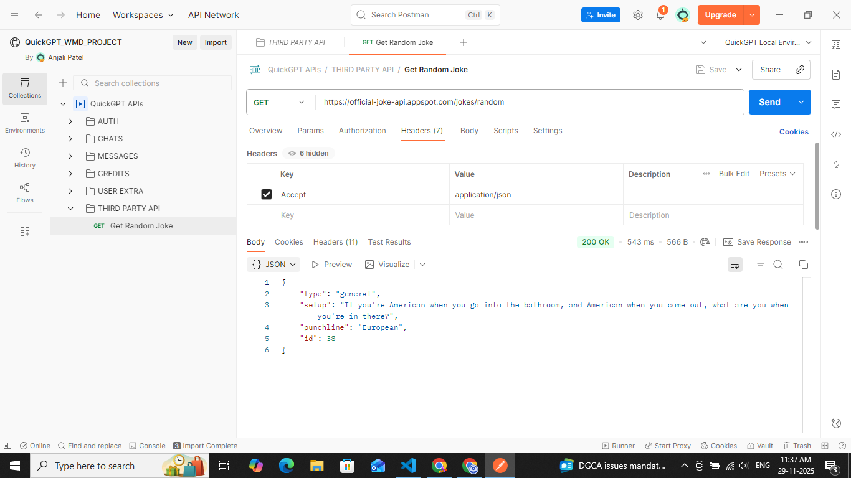

# Justification : motivation, benefits, and need

# QuickGPT is built to give users a simple and reliable way to use AI for text and image generation without dealing with complex setups or high costs. Moden AI tools are powerful but expensive, so there is a real need for a controlled, secure and scalable platform that offers these features in a practical way.

* **Motivation :** 
  + Users want quick access to AI chat and image tools in one place
  + AI APIs cost money, so a credit-based model is necessary to prevent misuse
  + Developers need a real-world project that covers authentication, payments and API integration
  + Secure, fast and responsive wen apps are now standard expectations
* **Benefits :** 
  + Unified platform for chat, image generation and community posts
  + Fair usage through credit-based billing
  + Safe login and secure payments using JWT and stripe
  + Scalable architecture using react, node.js, and mongoDB
  + Engaging experience through a community gallery
* **Need :** 
  + MERN stack provides speed, flexibility and easy scaling
  + JWT enables clean, stateless authentication for API routes
  + Stripe handles payments safely without exposing sensitive data
  + Backend gatekeeping is essential to validate credits before calling expensive AI APIs
  + Proper architecture ensures performance, maintainability and controlled AI usage